CURRICULUM VITAE  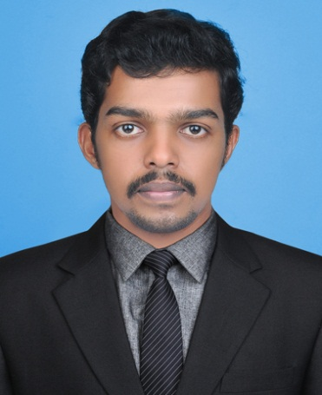  SARESH  SARESH.372403@2freemail.com  PERSONAL DETAILS  D.O.B: 26/10/1989  SEX: MALE  NATIONALITY: INDIAN | Career objective  To work in a challenging and dynamic environment, which gives me an opportunity to add value to the company and enhance my knowledge and continues development of upgrading knowledge by execution of vested responsibilities by the organization with loyalty and integrity.  Profile  - Committed worker  - Ability to think innovatively, creatively and logically  - Possess excellent verbal and written communication skills  - Possess excellent time and management skills  - Good team player and enriched with the ability to learn new concepts & ideas  - Adaptability to new environments, Quick learner and ability to perform tasks within deadlines.  PROFESSIONAL Experience  - Accountant, Mareena Tex, Tiripur, Tamilnadu, India.  (June 2010- July 2011)  - Accountant, Raja Enterprises,Vatakara, Kerala,India  (July 2013- December 2014)  Role and Responsibilities:  - Communicate with Customers about company offers  - Enter day-to-day sales , purchase and other transactions.  - Planning sales strategies  - communicate with sales representative  - Co-ordinate Sales team , Operation Team , and Customers  - Accounting in tally software and billing  - Maintain Cash book  - Dealing with Bank related activities  - Maintain sales report
LANGUAGES KNOWN  - ENGLISH  - MALAYALAM  - HINDI  - TAMIL  COMPUTER KNOWLEDGE  - MS- OFFICE  - TALLY  - SAP  - MACRO (EXCEL)  - SCRIPT (SAP)  - TYPEWRITING | - Finance and Accounts Associate, (F&A Cargill Foods India) EXL,Kochi, Kerala, India.  (December 2014 to September 2016)  Role and Responsibilities:  - Sales and distribution transaction in SAP  - Preparing critical MIS report  - Bank reconciliation in SAP.  - Orientation and guidance to newly joined employee.  - Implementation for Excel automation (Macro)  - Automation of SAP Transactions.  - Various critical MIS reports preparation and circulation, which includes MTD Sales report, All India stock report, Cheque bouncing report, Cheque inventory report, Cash Discount Report, Security Deposit Report, Manual debit/credit note report, EOM AR report, FRIR (Freight Received Invoice Received) Report , contribution reports position matching reports ,physical stock reporting to exchange and inventory rates verification etc.  - Voluminous O2C/P2P/Inventory Management and related transaction processing under stringent timeline, which includes - Sales order to invoicing, Purchase orders, Purchase requisitions, Stock transport orders, Contracts, Goods and service receiving, Process orders, Return and reversal of orders, Inventory adjustments, Credit note and Debit note, Cancellation and modification of documents, Cash journal, Internal order creation and settlement, Physical stock uploads, Bank guarantee uploads, process reviews etc.  - Centralized and Decentralized Material Ledger Run Transactions.  - Implementation and modification of SAP Script and Macros.

Academic Qualification  MBA (75%)  M.COM (60%)  B.com (64%)  PLUS TWO (75%)  SSLC (62%) | - Senior Finance and Accounts Associate, (F&A Cardinal Health) XEROX, Kochi, Kerala, India.  ( September 2016 to July 2017)  - Open PO follow up  - Invoice processing  - Auditing the day to day transaction  - Maintain daily reports and allocations of work.  - Vendor communication regarding invoice processing.  - Implementation for Excel automation (Macro)  - Fixing issue in EDI Transactions.  - Orientation and guidance to newly joined employee.  - Preparing payment register.  - Creation of SAP Script.  ACHIEVEMENTS  - Won ‘Star of the Year’ award while working with EXL Service Ltd, Kochi.  - Won Special excellence and Extra Miler Award in EXL Service Ltd, Kochi.  - Won Extra Miler Award in Customer Appreciation award in EXL Service Ltd, Kochi.  - Won ‘GEM (Gong Extra Mile) Awards’ of EXL Service Ltd for performance.  - Customer Appreciation Award and won best performance award in Xerox.  DECLARATION  I hereby declare and affirm that all particulars mentioned above are true to the best of my knowledge and belief.

