Curriculum Vitae
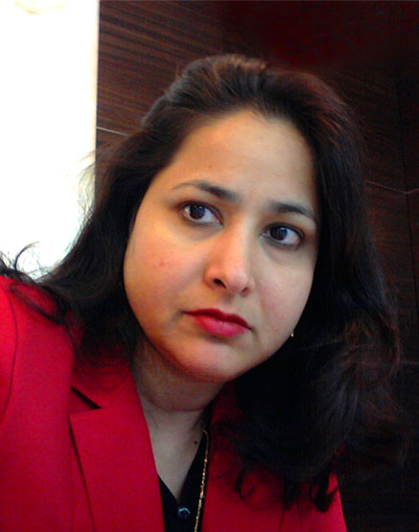

Leena
Leena.372412@2freemail.com

SUMMARY

Over a decade of extensive UAE experience in an Executive Secretarial position with a high level of discretion, confidentiality and professionalism. I am a dynamic, proactive, flexible person having keen attention to detail, which this role certainly requires for the overall growth of the organization. Able to multi-task and prioritize effectively whilst also taking advice and direction and yet provide a good service, ability to cope with aggressive deadlines and work under pressure.

Ability to prioritize incoming requests, balancing multiple demands and ensuring tasks are completed to the highest level of quality. Always willing to gain a comprehensive understanding of the company’s business to provide exposure to a variety of different business units, contacts, and levels within the organization. Excellent interpersonal, written and oral communication skills.

Currently working as an Executive Assistant to the Chairman of the Group.

OBJECTIVE
Seeking an Executive Secretarial position with a high degree of responsibility that requires experience providing administrative support to high-level executives & looking forward to work in a professionally competent environment where my organizational and communication skills can be fully utilized to assist executives in daily tasks.

PERSONAL INFORMATION

Name: Leena
Nationality: Indian
Religion: Christian
Qualification: B.Sc. (Hons.) Chemistry
Marital Status: Single

EDUCATIONAL QUALIFICATION

St. Stephen’s College, New Delhi, India
Graduated in Chemistry Hons. with Major in Organic, Inorganic and Physical Chemistry with First Division.

Carmel Convent School, New Delhi, India
Completed my All India Senior School Examination (C.B.S.E.) (10+2) with First Division in Science, English and Maths.

ADDITIONAL QUALIFICATION

Post Graduate Dipl. in Business Mgmt., YWCA, New Delhi, India
The course included Finance Mgmt., Marketing Mgmt., Personal Mgmt., Business Law and Business Economics, passed with First Division.

EMPLOYMENT HISTORY

Executive Assistant to the Chairman

Sun & Sand Sports, Dubai, U.A.E.

October 2011 – Till Date

Key Responsibilities
- Extensive diary management of a busy and complex schedule, including organization and prioritization of all internal and external meetings, ensuring effective use of time;
- Scheduled and planned the Board Members’ diary and events to ensure there were no double bookings and clash of meetings.
- Extensive travel management including international travel, ensuring itineraries are produced and where appropriate visas are arranged in a timely manner;
- Arrangement and co-ordination of large meetings, including external guests and assisting the Board Members in coordinating the agenda for Board meetings;
- Briefed the Board Members on the status of events with respect to meetings, appointments, functions and projects to ensure smooth running of his office;
- Producing PowerPoint presentations and other key documentation for key meetings;
- Tracked outstanding reports from Departmental Heads and Regional Managers which led to efficiency in meeting deadlines;
- Processing travel expenses, reports and reimbursements;
- Created highly effective organizational and filing systems, including quick and thorough indexing, filing and off-site storage resulting in easy access to critical information and streamlined office functioning.
- Act as a professional point of contact at all times for internal and external contacts;
- Pro-active and able to demonstrate responsiveness and ability to execute accurately;
- Work closely with the other PAs to share information and provide support as required;
- Printing/ collation of confidential/ sensitive documents.

Personal Assistant to the Vice-President

Henkel Jebel Ali FZCO, Dubai, U.A.E.

February 2010 – September 2011

Key Responsibilities
- Manage the Vice-President’s daily agenda;
- Facilitating business travel & hotel arrangements for the VP i.e. arranging tickets, hotels, visas, transport to/from hotel;
- Facilitate & co-ordinate smooth operation between the VP and other Business Units;
- Organizing internal and external meetings and other official engagements, booking meeting rooms, conference bridge set-up;
- Arranging and booking conferences, transport to/from the venue, lunch bookings, ensure that projectors, flip charts, audio-video setup etc. are in place;
- Maintaining & updating the travel schedule for the VP and his direct reports;
- Receiving guests/visitors and conducting proper protocol;
- Follow-up on the work delegated by the VP to his staff to ensure their full and timely completion;
- Attend to the VP’s mail box and proactively delegate to the respective Business Heads;
- Tracking of all key deadlines and notify VP or responsible Business Units Heads as they become due;
- Day to day general secretarial duties such as typing correspondence emails, receiving telephone calls, filing and other routine secretarial and administrative duties.

Executive Assistant to the Chief Technology Officer

The Royal Bank of Scotland plc, Dubai, UAE.

April 2008 – February 2010

Key Responsibilities
- Manage CTO’s daily agenda by organizing internal and external meetings and other official engagements, booking meeting rooms, lunch bookings, conference bridge set-up;
- Maintaining the manual leave tracking of comp-off, updating the monthly Training Calendar and Error Log;
- Arranging monthly ITM/ITLT meetings & off-sites;
- Organizing flight bookings, hotel accommodations& visas for business delegates;
- Assist and co-ordinate in the smooth operation of various departments;
- Tracking of all key deadlines to ensure full and timely completion of the task assigned;
- Execute normal secretarial task: photocopying, attending to postal mail, filing, email follow-up, filtering of phone calls, handling self-correspondence and other routine administrative & secretarial duties.

Executive Secretary to the Chairman

Albwardy Investment (Spinneys Dubai), Dubai, UAE.

December 2002 – March 2008

Key Responsibilities:
- Main duties involve independently handling self-correspondence, file maintenance, data management and handling routine administrative & secretarial duties;
- Organizing internal and external meeting and other official engagements;
- Facilitating business travel, booking conferences & hotel for senior management;
- Receiving guests/visitors and conducting proper protocol
- Proficient in computers with excellent typing and business correspondence ability well versed with Windows Vista, Windows XP packages such as MS Word, MS Excel, Power-point, MS-mail/Internet and Multi-media.

