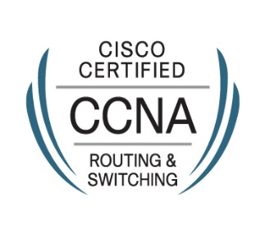
Nithish
Nithish.372423@2freemail.com
-

Professional Summary
Resourceful Cisco-certified Entry Level Network Engineer committed to performing assigned tasks while working in a fast-paced environment. Adept at identifying system performance and operational issues. Specialize in designing implementing and maintaining networking infrastructures.

Academic Profile
- B-Tech -Electronics and Communication from Calicut University with 67%
- AISSCE from CBSE with 76%
- AISSE from CBSE with 75%

Experience
Technical Support Engineer (Oct 23, 2015 – Oct 31, 2016)
Brainwork Technologies, New Delhi
- Monitor the network of the client through network management systems (NMS Tools)
- Keeping a check on performance of the network and notify alerts to the technical team through emails and calls
- Maintenance of networking systems
- Providing computer support services both for software and hardware for employees of organization
- Troubleshooting routine problems and maintenance of servers (Windows Server 2008)

Technical Skills
Networking-CCNA 200-125 (CISCO ID : CSCO13098897)
- Hands on experience of Cisco – 1800,1900,2600,2800,2900 series Routers
- Hands on experience of Cisco – 2900,3500 series Catalyst Switches
- Configuration of Routing protocols (Static, RIP V1 & V2, EIGRP and OSPF)
- Extensive knowledge of Standard and Extended ACL
- Extensive knowledge of NAT and PAT
- Hands on experience of Cisco Routers Backup, Recovery and Password breaking
- Implementing LAN and WAN connections using Switches and Routers
- Setup of Layer 2 switching and STP
- Configuring and troubleshooting PPP, Frame Relay, RIP, EIGRP, OSPF, VLAN, VPN and Trunking
- Hands on experience in NMS Tools, Firewall Management, Virtual Box,GNS3,VMware etc

Operating systems-Windows (XP , 7, 8, and 10) , IOS (CISCO),Windows Server 2008
Software-Cisco Packet Tracer, GNS3, Adobe Photoshop CS6 , Skype, Microsoft office (Word Excel, Outlook)

Training and Certifications
- Networking training from Jetking, Vikaspuri
- Cisco Certified Network Associate in Routing and Switching
- Automation Training from SR Thermonix, Ghaziabad

Personal Profile
Date of Birth: 14 – 02 – 1992

Visa Status: Visit Visa (Expires on 1st week of November)

