MOHAMMED
MOHAMMED.372426@2freemail.com 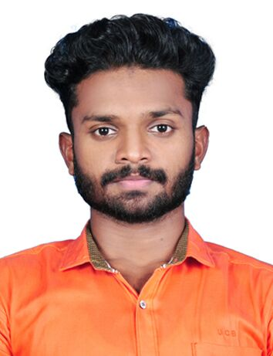

Career Objective
Seeking a challenging position in a professional environment that enables to be more dynamic, to utilize strengths and skills to the fullest, where my aspiration to advancement will contribute to the organization’s growth and development.

Education
- B.com (Co-operation)
- XIIth from G.H.S.S Chundampattawith 76.00%.
- Xth from G.H.S.S Chundampatta with 70.00%.

Technical Skills

- TALLY
- MS Office
A fast learner and good at reproducing and applying techniques and proven strength in problem solving, co-ordination and analysis
Work Details
- Asian Traders (ALeading Sole proprietor shipUnit) in Pattambi (Kerala-india) as an Accountant(From 1st January 2016 To 30th June2017).
- Working as Sales Executive in Shark Catering ServicePattambi ,Kerala. Since February 2014
Key Responsibilities:-
- Worked to achieve a certain amount of sales on monthly basis
- Research and learned about company products , to be prepared for customer questions.

Area of Interest

- Accounting,
- Management Accounting.
Personal Strengths
- Good Leadership
- Ability to Work in a Team
Weakness
- Trust People Very Quickly
- Iam Restless Until I Don’t Finish My Work, That Day Itself
Hobbies
- Traveling
- Playing Football
Declaration
I MOHAMMED AJMAL hereby declare that the information given above is correct to the

best of my knowledge.

