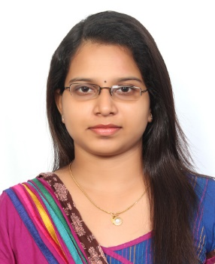
SOUMYA

Soumya.372437@2freemail.com

Nationality - INDIAN

To contribute as a team member in a firm with professional work driven environment where I can utilise and apply my knowledge, skill which would enable me to grow while fulfilling organisational goal.
- Academics:

- MBA in HR and Marketing (2012-2014) from Bishop Jerome School of Management (University Of Kerala)
- Degree in Computer Application (2008-2011) from Fatima Mata National College, ( University of Kerala).
- Higher Secondary (2006-2008) from Sree Narayana Yogam School (Kerala State Educational Board)
- SSLC (2005-2006) from Vimala Hridaya Higher Secondary School (Kerala State Educational Board)

- Experience:

ADMINISTRATIVE OFFICER at MANNAM MEMORIAL NSS COLLEGE located at KOLLAM, KERALA, INDIA from 12th July 2016 to 13th January 2017.

- Key Deliverables-

- Supervise the daily operations of the Institution.
- Performing administrative duties.
- Resolve administrative problems and inquiries
- Maintain files and records
- Developing and implementing the Institutions strategic plan.
- Motivating staff

FACULTY MEMBER in MANAGEMENT and MARKETING STUDIES at MANNAM MEMORIAL NSS COLLEGE located at KOLLAM, KERALA, INDIA from 12th July 2016 to 13th January 2017.
- Key Responsibilities-

- Effective classroom teaching
- Evaluating students’ academic performance
- Maintaining students record
- Help students identify and achieve their educational goals

ASSISTED HR DEPARTMENT at DR NAIRS HOSPITAL, a 300 bedded multi-speciality hospital located at KOLLAM, KERALA, INDIA from OCTOBER 2014 to NOVEMBER 2014.

- Key Responsibilities-

  - Leave and attendance management
  - Recruitment
  - Training
  - Performance Appraisal

- Skills:
- Time management
- Ability to deal with people diplomatically.
- Willingness to learn, Team facilitator.
- Analytical and problem solving skills
- Decision making skills
- Effective verbal, listening and written communications skills

- IT Skills:
- Well versed with Windows 7, 8, 8.1, MS Office (Power point, Word and Excel)
- Personal Information:

- GENDER | FEMALE
- MARITAL STATUS | MARRIED
- RELIGION | HINDU
- VISA STATUS | HUSBAND’S VISA
- LANGUAGES KNOWN | ENGLISH, MALAYALAM, TAMIL.

- Reference:
On request

