CURRICULUM VITAE

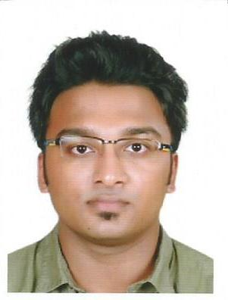
Babish
Babish.372456@2freemail.com

CAREER OBJECTIVE
Aspiring to work with an organization that offers responsible position where I can utilize my skills and capabilities to carve a niche for myself and effectively deliver towards contributing to the organization’s aspirations and also enhance my personal growth through continual upgrading of knowledge.
QUALIFICATION
BACHELORS:
B.E CIVIL ENGINEERING - September 2012 -December 2016
SNS College of Technology, Affiliated to Anna university Chennai.
Percentage: 6.02 cgpa
HSC(Mathematics with science):
Good Shepherd Matriculation and higher secondary school, Marthandam.
Percentage: 72
SSLC:
Our Own High School, Al Warqa,Dubai
Percentage: 7.4 cgpa
EXPERIENCE
6 months in India – Worked as a Site engineer for G+1 House contruction.
SOFTWARE PROFICIENCY
- Auto CAD (2D)
- Primavera
- Microsoft Office

CERTIFICATIONS
- Professional in project Planning and Management using Primavera.
INTERNSHIP

- Undergone internship in PACY exports and imports in Netherlands via INCO business group (Natural stone market analyzing, and client meeting for analyzing local business in Belgium and Amsterdam)
STRENGTH
Interpersonal:

- Good communication and interpersonal skills,
- strong written and spoken communication,
- Multi lingual : fluent English, Hindi, Malayalam,Tamil,
- Soft-spoken,
- Problem solving and decision making,
- Ability to work in challenging environment and learning from adverse situations,
- Meticulous and a Quick-learner.
VISA STATUS
3 months visit visa( valid upto-18th November 2017)

PERSONAL INFORMATION
Date of Birth | : | July 26th,1994
Marital Status | : | Unmarried
Languages Known | : | English, Hindi , Malayalam, Tamil, Arabic(R&W)
Other details : | : | Holding valid Indian driving license

I hereby declare that above mentioned information is correct and best to my knowledge.

