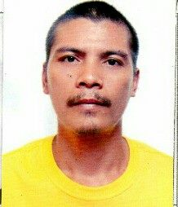
MICHAEL
MICHAEL.372469@2freemail.com
Objective:
Obtain a position where I can enhance my skills and experiences. Explore new challenges and acquire new knowledge for my profession.
HIGHLIGHTS
Dedicated team player Check up wiring Testing the unit
Operation expert Clean the unit Change the spare parts
Adaptable Trouble shooting
Knowledge in refrigeration system Installation
Preventative maintenance Change the freon

PERSONAL INFORMATION :

Birthdate: October 29, 1982
Birth Place: Lanao del Norte
Age: 34 yrs old
Height: 5’11”
Weight: 68 kl gram
Citizenship: Filipino
Status: Married

EDUCATIONAL BACKGROUND:
TERTIARY Santa Monica College
1st yr
SECONDARY Kauswagan National High School
2000-2001
VOCATIONAL Santa Monica Institute Of Technology
WORK EXPERIENCE:
- FLERICS APPIANCES SERVICE CENTER
Position: Refrigeration and Air conditioning Technician
October 2012-2015
- LANCE REFRIGERATOR SERVICE CENTER
Position: Technician / Company Driver
2014-2017

