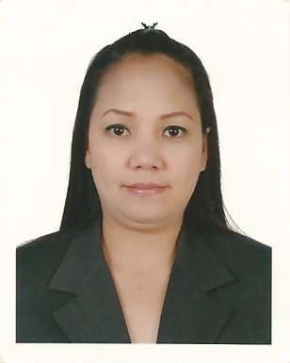
RUTH
RUTH.372470@2freemail.com

OBJECTIVES:

- To obtain a challenging position that is the same with my professional experiences in progressive and growth oriented company.
- To work for an organization that recognizes abilities, talents and accomplishments of an individual.

EDUCATIONAL ATTENMAINT:

Associate in Pharmacy (Undergraduate)
Lyceum-Northwestern University, Dagupan City Philippines

STRENGTH, SKILLS AND CAPABILITIES:

- Can work independently.
- Honest and trustworthy.
- Can work without supervision.
- Hardworking and dedicated to work.
- Solve problems efficiently
- Time Management
- Strong leadership and collaboration
- Adaptable from being creative

WORK EXPERIENCE:

March 18, 2012 – December 31, 2017 WAITRESS and CASHIER
Baity Hotel Apartment
Bur Dubai, Dubai

Waitress
- Providing excellent wait service to ensure satisfaction
- Taking customer orders and delivering food and beverages
- Making menu recommendations, answering questions and sharing additional information with restaurant patrons
- Follow all relevant health department regulations
Cashier
- Always observed cleanliness.
- Count money in cash drawers at the beginning of shifts to ensure that amounts are correct and that there is adequate change.
- Receive payment by cash, check, credit cards, vouchers, or automatic debits.
- Issue receipts, refunds, credits, or change due to customers.

Oct. 2006 - Jun. 2011 SALES CLERK
Avenue Mall Kuwait

- Maintain the cleanliness in the selling area.
- Entertaining the customer with full attention.
- Replenishment or replacement of items.
- Checking the merchandise/items.
- Preparing of inventory.
- Preparing voucher items.
- Preparing wholesale receipts.
- Preparing of daily sales quota and sales report.

2004 – 2006 Service Crew
Jollibee Food Corporation - Dagupan City, Philippines

- Generally the duties include delivering the food and beverages.
- Removing used dishes, setting up and taking down tables and taking orders.
- The responsibility is to make sure the customers are satisfied.
- Provide excellent customer service to guests
- Carry dirty plates, glasses and silverware to kitchen for cleaning
- Inform customers about the day’s specials
- Greet and escort customers to their tables
- Up-sell additional products when appropriate

2002 - 2003 Merchandiser
SM Shoe Mart - Pasay City Philippines

- To promote and sell the products to the customers.
- Displaying the company.
- Targeting monthly revenue.
- Smile always to attract customer’s attention.
- And especially always know the product.
- Service oriented.
- Stock shelves, counters or tables with merchandise.
- Keep record of sales, prepare inventory of stock and order merchandise.
PERSONAL DETAILS:

Nationality : Filipino
Marital Status : Single
Birth Date : October 26 1975
Gender : Female
Languages : English, Tagalog
Visa Status : Employment Visa

I hereby attest that the above mentioned information is true and correct.

