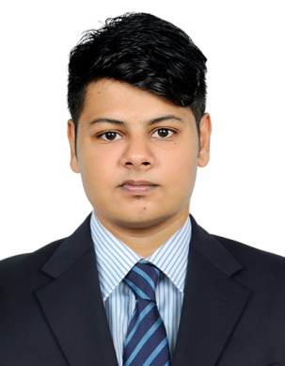

Manoj
Manoj.372472@2freemail.com
Career Objective
To have a growth oriented and challenging career, where I can contribute my knowledge and skills to the organization and enhance my experience through continuous learning and teamwork
Academic Qualification
Course | University/Board | Institute | Year of passing | Percentage/CGPA
B.E- Mechanical Engineering | Anna University | TamilNadu College Of Engineering, Coimbatore, Tamil Nadu. | 2016 | 6.28
HSC | CBSE | Bhavans Vidya Mandir, Elamakkara, Kochi, Kerala. | 2012 | 68.6
SSLC | CBSE | Bhavans Vidya Mandir, Elamakkara, Kochi, Kerala. | 2010 | 8

Additional Skills And Software Proficiency
  - Software : AutoCad,Sketch up.
  - Office suite : MS-office
Area of Interest
In all areas of Mechanical Engineering preferably
  - Design and Manufacturing
  - Alternate fuels and energy resources
  - Automobile Industry (production and maintenance)
Project
  - Project Area : Mechanics
  - Project Title : “Design and fabrication of mechanical can
crusher”
Project Area : Automobile engineering
  - Project Title : “Design and fabrication of 50cc mini bike”
Project Area : Automobile Engineering
  - Project Title : “Improvement In Production in ABDS
Assembly Line”
Project Area : Automobile Engineering
  - Project Title : “Study and Rectification of defect in Socket
Of Cables”
Industrial Visits And Inplant Training
- Institute of Road and Transport Technology (IRTT), Erode.
- Gates Unitta India Private Limited, Chennai.
- Shree Ashwn Industries, Sriperumbadur, Chennai.
Work Experience

- Shree Ashwn Industries : 01-July-2016 to 30-April-2017

Workshops undergone
Work shop:
- Recent Trends In Automobile : Kumaraguru College Of Technology,
Coimbatore. (BOSCH).
- Automotive Power Train Engineering: Tamil Nadu College Of Engineering,
Coimbatore And Technology
(Experts Hub Industry Skill Development).
(IIT BOMBAY).
- Solar And Wind Energy Systems : Coimbatore Institute Of Technology.

Achievements and Extra-curricular activities
- Secured Third Place in Anna University Zonals for football 2014-2015.
- Participated in CBSE district football tournament for the school team 2011-2012.

Bike Race
- Participated in 50cc category “YUGAM 2015” national level mini dirt bike event conducted by Kumaraguru College Of Technology, Coimbatore.

Personal Profile

Date of Birth : 07–07-1994
Gender : Male
Marital Status : Single
Languages Known : English, Hindi, Malayalam, Tamil.
I hereby declare that all the details furnished here are true to the best of my knowledge.

