CURRICULUM – VITAE

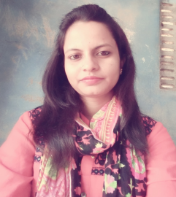

PAPIYA

PAPIYA.372477@2freemail.com

Objective:
- To secure a creative and challenging position which will utilize my practical and theatrical experience and planning and provide opportunity for professional and personal growth.

Summary:
- Goal oriented professional with three years of experience as assistant teacher.
- Worked with Dream India schools, West Bengal, India as a mother teacher.
- Worked with DELHI PUBLIC SCHOOL, Gujratat, India as assistant teacher.
- Abilities in handling multiple priorities with a bias for action and a genuine interest in professional development
- Team player with strong analytical and leadership skills

Professional Experience | - Worked with Dream India schools from 18th November 2015 to 31th August 2016.  - Worked with DELHI PUBLIC SCHOOL from 1st February 2014 to 24th April 2015 as assistant teacher.  - Worked with ILSOBA AUROBINDO SHISHU SIKHA NIKETAN, from June 2010 to March 2011.
Strength: |  | - Ever-Ready to Work.  - Helping Hand.  - Empathic Learner.  - Easy Adaptable to any environment.  - Self-Motivated. Excellent communication skills  - Can accept responsibility.  - Quick decision making.  - Disciplined and loyal.  - Team work
Role and Responsibilities | - Taking class as teacher.  - Organized school cultural program.  - Planning exam schedule.  - Maintained class documents.

Computer skill | Microsoft word, excel, power point, Etc.
Education Qualification
MASTER OF ARTS | Completed from THE UNIVERSITY OF BURDWAN, India in 2010.
B.A ( Bengali honours) | Completed from THE UNIVERSITY OF BURDWAN, India in 2008.
HIGHER SECONDARY | Completed from W.B.C.H.S.E in 2005.
MADHYAMIK | Completed from W.B.B.S.E in 2003.

Personal Information:
Date Of Birth: | 12th November 1986
Gender: | Female
Languages: | English, Bengali and Hindi.
Visa status: | UAE Residence visa
Nationality : | Indian

Declaration: I do hereby declare that the above information is true to the best of my knowledge.

