Abuthahir
~ Finance & Accounts ~ General Administration
Abuthahir.372519@2freemail.com
Key Skills  Finance & Accounts  Administration  Commercial Operations  Team Building & Leadership  Compliance Management  Soft Skills | A proficient analyst with expertise in strengthening companies to lead in highly  Competitive situations.
 | Profile Summary
- A competent professional with over 8 years of experience in Finance & Accounts, General Administration and Financial Reporting & Analysis
- Prepared and explained weekly profit & loss projections; established product line profit & loss statements to identify opportunities and risks
- Proficient in managing various activities like office administration, reconciliation of creditors and debtors accounts
- A result-oriented individual with strong analytical, communication, interpersonal and organizational skills

 | Career Timeline
Change Agent  Motivational Leader  Thinker  Collaborator  Communicator  Planner | 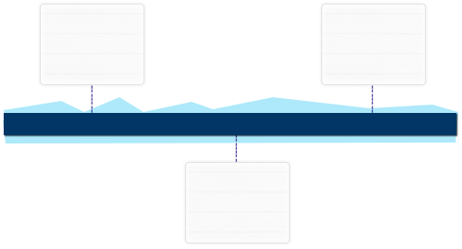  Sep’05- May’08  Salem Abdullah Rashidi & Sons Co as Genereral Accountant  June’08-July’13 Feb’13  Mar’14- Jan’17  Gold Park Jewellery as Cashier  Dhofar Electricl Cont. Co LLC as Accountant
Education
- B.Com. from University of Calicut in 2004

Work Experience

March’14- Jan’17 with Dhofar Electrical Cont.Co LLC, Oman as Accountant

Key Result Areas:
- Administering all ledger accounts; preparing and analyzing accounting records, financial statements and other financial reports to ensure accuracy
- Managing office administration, cash book management, petty cash management, monthly bank reconciliation statements while resolving the differences in timely manner
- Facilitating the preparation of salary statement for bank and office; maintaining book of accounts as well as following up for the payments
- Monitoring accuracy of information contained in financial reports and providing them to Auditors
- Performing various activities like all types of invoice preperations, credit control, quotation preparation
- Performing in the role of document controller for Electrical Projects and activities like obtain approvals for drawings from concerned authorities like municipality, water ,telephone departments

June’08 – July’13 with Salem Abdullah Rashidi & sons Co, Oman as General Accountant

Key Result Areas:
- Administering all general ledger accounts; preparing and analyzing accounting records, financial statements and other financial reports to ensure accuracy
- Managing office administration, cash book management, monthly bank reconciliation statements while resolving the differences in timely manner
- Facilitating the preparation of salary statement for bank and office; maintaining book of accounts
- Administering the operations relating to the transportation of heavy Vehicles and Equipments
- Performing the activites like preparing the all types of invoicepreperation ,quotations and L/C
- Providing books of accounts and necessary information contained in financial reports to Internal and External auditors

Previous Experience
Sep’05 – May’08 with Gold Park jewellery , Kerala as Cashier

IT Skills
- Proficient with the usage of MS-Office, Tally 9, Peach-tree Accounting,A+ Hardware course

