Ruby
Ruby.372530@2freemail.com
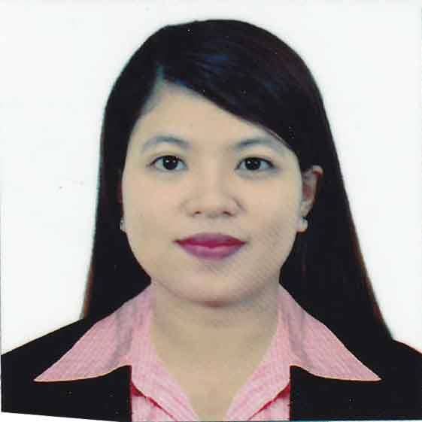

sUMMARY
Dedicated and focused Administrative Assistant who excels at prioritizing, completing multiple tasks simultaneously and following through to achieve project goals. Answers a high volume of incoming calls while handling in-persons inquiries from client and colleagues. Flexible and hard working with strong drive to succeed.

SKILLS
- Using office equipment.
- MS office Suite including PowerPoint, Excel and Word.
- Internet and Email.
- Professional phone etiquette.
- Time management specialist.
- Proficient record keeper.
- Ability to maintain confidentiality.
- Friendly and Hospitable.

Experience
10/15/2013 to present | ABLE MINDS THERAPY CENTER
- Greeted customers and guided them appropriately
- Typed, copied and distributed mail and form.
- Filed chart and other records
- Assisted with billing and reporting functions
- Schedule and coordinate meetings and events

Education
Under graduated STI COLLEGE QUEZON CITY - Fairview
BACHELOR OF SCIENCE IN INFORMATION TECHNOLOGY

PERSONAL DATA
Birth Date : July 29, 1991
Age : 26 years old
Status : Single
Gender : Female
Nationality : Filipino

References
References are available on request.

