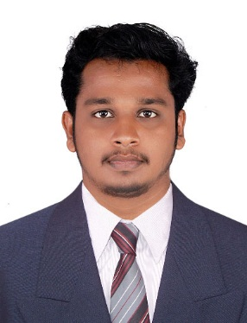 |  | Ranjith.372566@2freemail.com
 |  |  |  | Profile Summary
To secure an Engineering / Technical position in an established organization which I could contribute to as a Graduate Engineer with a positive work ethic, willingness to learn and work hard. A perfectionist who works confidently with own initiative and able to spearhead team. In return I am seeking long term career and advancement in opportunities with the organization. Well-organized and result driven team player with strong communication, coordination, problem solving, and time management skills. Familiar with designing software (AutoCAD/Electrical CAD software). Expecting potential for growth within the industry hierarchy.

 |  |  |  | Areas of Expertise
- Good Knowledge about power transformer and maintenance.
- Good Knowledge in SF6, Air circuit breakers operations and maintenance.
- Good Knowledge in Motor starter modules, VFD control of AC motors.
- Able to interpret and explain various technical manuals of substations.
- Working experience about various HT and EHT substation installations.
- Good Knowledge in Auto CAD / Electrical CAD.
- Effective communication and interpersonal skills.
- Strong time management and organizational skills.
- Possess knowledge in technically proficient with MS-Office, MS-Excel, PowerPoint Presentations & Documentation, good knowledge in windows operating system.

 |  |  |  | Proven Job Roles
- Daily job planning, scheduling and execution of Electrical works.
- Carrying out hourly inspection of all substation equipment’s and to verify whether all installations are in healthy mode and within Operational limit.
- Achieving the targeted plant availability by effectively implementing preventive maintenance schedules and condition monitoring etc.
- Maintenance of Transformers up to 1500 kVA, 11kV VCB, LT ACBs & Induction Motors up to 250 HP.
- Preventive maintenance of Motor Control Centers (MCC).
- VFD control of AC motors.
- Preventive maintenance of Circuit breakers.
- Preventive maintenance of Current transformers and Potential transformers.

 |  |  |  | Education
B. Tech Electrical Engineering, Cochin University (CUSAT), India. |  |  |  |  | 2014
Secondary Education, HSE, Kerala. |  |  |  |  | 2010
Primary Education, SSLC, Kerala. |  |  |  |  | 2008
 |  |  |  | Academic Projects
MINOR

- ULTRASONIC PROXIMITY DETECTOR

MAJOR

- HYBRID POWER GENERATION OF WIND AND SOLAR ENERGY WITH EFFECTIVE SOLAR TRACKING.

 |  |  |  | Career Snapshot
SITE ENGINEER |  |  |  | 04-12-2014 to 05-05-2015
Under an A Class Contractor

GRADUATE TRAINEE |  |  |  | 14-05-2015 to 13-11-2015
Kerala Minerals and Metals Limited (KMML)
OPERATOR 09-12-2015 to 10-06-2017
Kerala State Electricity Board
 |  |  |  | Global Certificates
AutoCAD.

Electrical CAD.

 |  |  |  | Technical Skills
Operating System | : |  | Linux, Windows.
IT Knowledge | : |  | C, C++, Microsoft Office.
Design | : |  | AutoCAD.
 |  |  |  | Personal Details
Nationality | : |  | Indian
D.O.B | : |  | 12-August-1990
Marital Status | : |  | Single
Passport Validity | : |  | Till 07-10-2024
Languages | : |  | English, Hindi, Malayalam
References | : |  | Available upon demand

