MELLOW
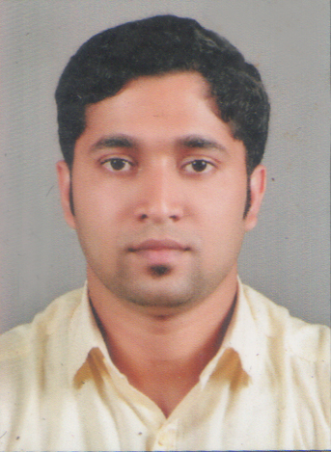
MELLOW.372567@2freemail.com
Master of Business Administration
Finance & Marketing

Objective
To work in a competitive and challenging environment, contributing to the best of my abilities towards the growth and development of a progressive company, make optimum utilization of my interpersonal and academic skills to pursue a challenging and rewarding career.

SKILLS
- Ability to work Co-operatively as part of a team with helpful and friendly attitude.
- Problem solving.
- Proficient in MS office, especially MS Excel and MS Word.

Professional Experience
Accounts Manager&Admin (Ayurcounty Resorts ,Munnar) November 2014 – July 2017
Ayurcounty Resort, (Classified under four star). offers a world of ultimate luxury within this cradle of enchanting bliss. Unlike conventional resorts, Ayur County is built up of posh two bed room villas surrounded by a lavish spread of unspoiled nature where it casts its spell on every drop of dew rendering a magic that sinks you into the tranquil plains above.

Responsibilities
- Overall responsibility for the accounting and payroll functions of the company.
- Continually seeking to improve accounting and administrative process by leading local development and implementation of financial application.
- Preparing P.F /ESIC calculations and make online payment after obtaining approval.
- Handling P.F Withdrawal of the employees
- Updating employee details as per the need of P.F/ESIC office requirement.
- Mentoring and developing the team and fostering a positive working environment.
- Preparing Full and Final Settlements of employees.
- Liaising closely with Financial Analysts and financial planning and analysis with calendar management, other cost analysis, revenue recognition.
- Being a discussion partner on all issues relating to payroll and fringe benefit, and pro-actively advising on labor law/fiscal issues and opportunities..
- Accounting, Payroll, And Administrative process
- Coach, Train, develop and evaluate the Accounting and payroll staff.
- Manage monthly cash forcast.
- Monitor vendor payments terms and disbursement to maximize cash benefits.
- Manage the inter-company process.
- Manage all the receipts and payments

Key Responsibilities

- To handle all the functions in Accounts department.
- Responsible for the preparation of the financial statement for 5 entities.
- Lead the local audit and relationship with our external auditors and with global Accounting.
Provide timely and meaningful financial reporting to local authorities the client global service.
Review monthly reconciliations to highlight areas of risk.
- Build and formalize various clients finance and accounting policies.
- Follow all company policies and procedures; ensure uniform and personal appearance is clean and professional; maintain confidentiality of proprietary information.
- Enhance internal controls, continuously seeking to reengineer local business process to obtain efficiencies and reduce cost..
- Enter Employees into the Punching System
- Create and maintain office correspondence.
- Responsible for the facilitating the preparation and review of multiple tax returns with support from external advisors.
- Continuously work on identification of tax opportunities and avoidance of tax risks in personnel tax, wage taxes, corporate tax and VAT.
- To listen and respond appropriately to the concerns of other employees.
- To have an overall checkup in all departments like Housekeeping, Restaurant, Store, Production etc.…

Education
- Master’s in Business Administration (Finance & Marketing),Marian International Institute of Management, MG University, Kuttikkanam, Idukki, Kerala , India, August 2014
- B.com,JPM College,Labbakkada, MG University, Kottayam, Kerala, India, December 2012
- Higher Secondary Examination, St.Domonics HSS Kanjirappally, Kerala State Board, March 2009

Achievements
- Participated in IRSSM (International Research Symposium In Service Management).
- Participated in various management fests, and other athletic meets.
- I was selected as the vice-president for the Finace&sports Club at college-

Personal Particulars
Date of Birth : 26/08/1990
Gender : Male
Nationality : India
Marital Status : Single
Visa Status : transferable
Languages Known : English, Malayalam, Hindi and Tamil

DECLARATION:

I do hereby declare that the particulars of information and facts stated herein above are true correct and complete to the best of my knowledge and belief.

