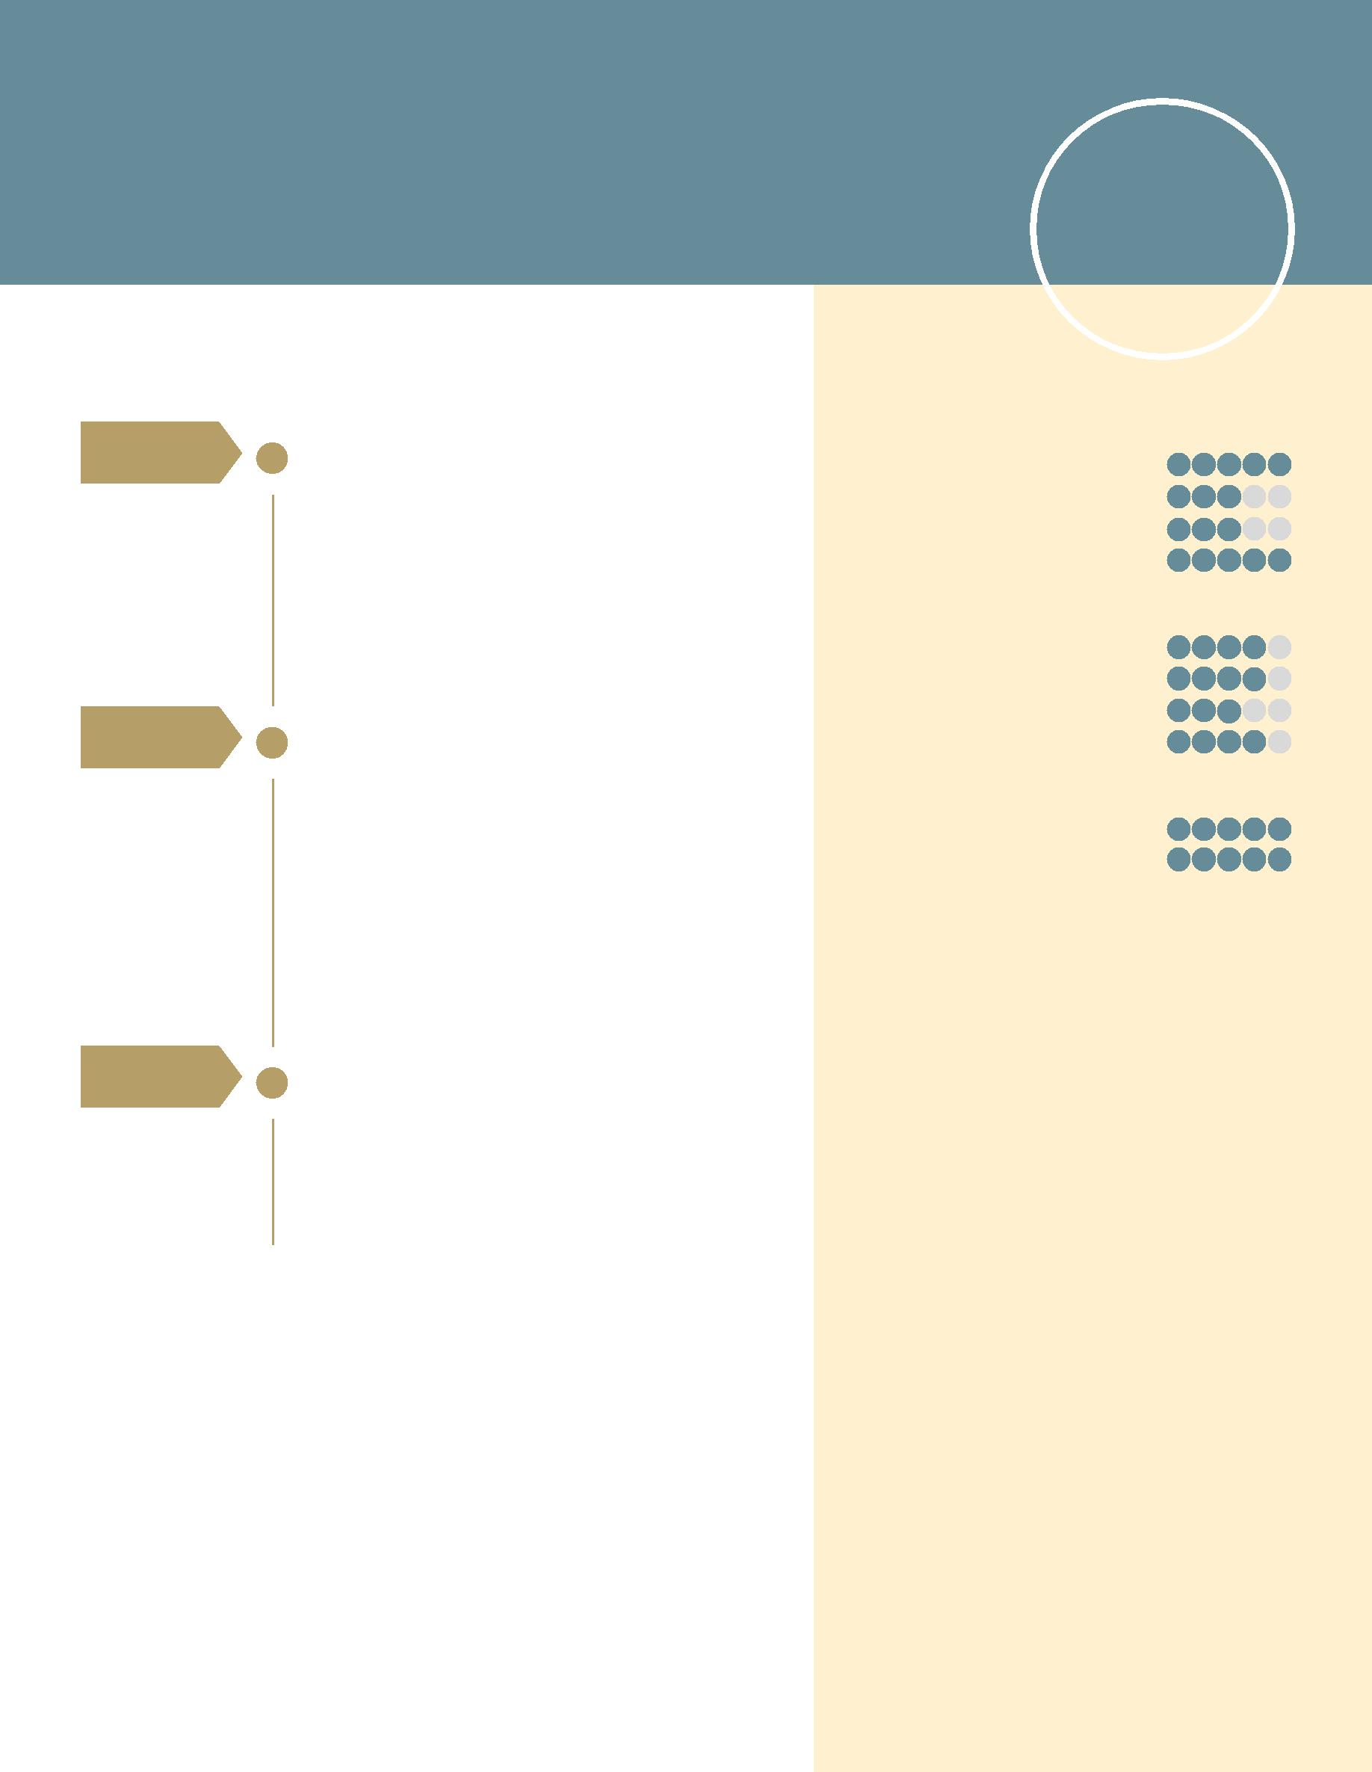Maram
Maram.372618@2freemail.com

Junior Architect

Experience

Dec 2016 – | INTERNATIONAL ADVISOR
Apr 2017 | Vodafone UK
 | Alexandria, Egypt

Skills

PROFESSIONAL

AutoCAD

Photoshop
Rivet

Feb 2016 –
May 2016

Jul 2015 –
Sept 2015

Role involves responding to customers of Vodafone UK over the phone and resolving their inquiries. The main purpose is to facilitate and provide a Vodafone global customer service standard

ARCHITECT ENGINEER

Dar Al Handasa & Al Emara Consulting
Engineers
Al-Ain, UAE

Assisted in the preparation of layout and drawing preliminary sketches of project to present it to the client. Assisted as well in the preparation of design development drawings. Provided support to Architects & management staff.

TRAINEE ENGINEER

Qassed Khair

Alexandria, Egypt

Observed the construction of Maspero building (Chanel 5)

Microsoft Office

PERSONAL

Sociable

Hardworking

Punctual

Reliable

LANGUAGES

Arabic

English

Education

BACHELOR OF ENGINEERING
Alexandria University, Alexandria

Department: Architecture & Construction Program (SSP)

2010 – 2015

IGCSE

Al-Ain Juniors School, UAE 2007 – 2010

References are available upon request.

