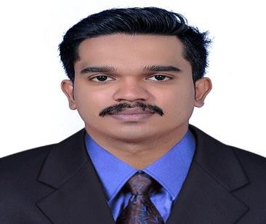
MUHAMMED
MUHAMMED.372649@2freemail.com
Operations executive
India

Exceptionally skilled Logistics Management Specialist brings
PROFESSIONAL SUMMARY
SKILLS
PROFESSIONAL
EXPERIENCE
One year and eight month of experience working with supply chain issues. Understand the complexity of logistical planning and execution. Have a Post-Graduation in Logistics and Supply Chain Management and an extremely analytical mind.

.
  - Prepare import export documents
  - Incoterms
  - Ware house management and Inventory control
  - Goods transportation
  - Shipment issues resolution
  - Relationships development
  - Multitasking
Extensive experience leading shipping, receiving and
logistics coordination with many local and national, domestic and international carriers
Keep good relation with customers
- Expert in MS office (Excel, word, PowerPoint)

Logistic Coordinator

SCM Shipping Service Pvt Ltd - Kochin
August 2014 October 2015

•
Performed logistics management functions involving Planning, coordinating, evaluating, and integrating logistics actions required to support channel customers, logistics missions/programs, and logistics processes.
  - Act as main point of customer contact
  - Provide shipment information to customers
  - Mediator with different departments within the company to easy shipments
Assist in tracking shipments and providing alternative
•
Information
Provide transportation information and manage billing
  - Information.
Recommend shipping solutions to minimize cost or
  - Environmental impacts.

•
Arrange delivery or storage of goods at destinations.

Operation executive

AIWA SHIPPINGS Pvt Ltd, Kochi
November 2015 April 2016

- Provide shipment information to customers
- Mediator with different departments within the company to easy shipments
- Assist in tracking shipments and providing alternative information
- Provide transportation information and manage billing information.
- Recommend shipping solutions to minimize cost or environmental impacts.
- Reserve necessary space on ships, aircraft, trains, or trucks.
- Arrange delivery or storage of goods at destinations.

EDUCATION

COMMUNICATION SKILL

PERSONAL INFORMATION
MBA Logistics and Supply Chain Management
Bharathiyar University 2014 2016

Bachelor of Commerce
Calicut University 2011 2014

English,Hindi,Malayalam And Tamil

Date of Birth: 02-July-1993 Nationality: Indian
Visa Status: 3 Month visit visa (till november 20/2017)

