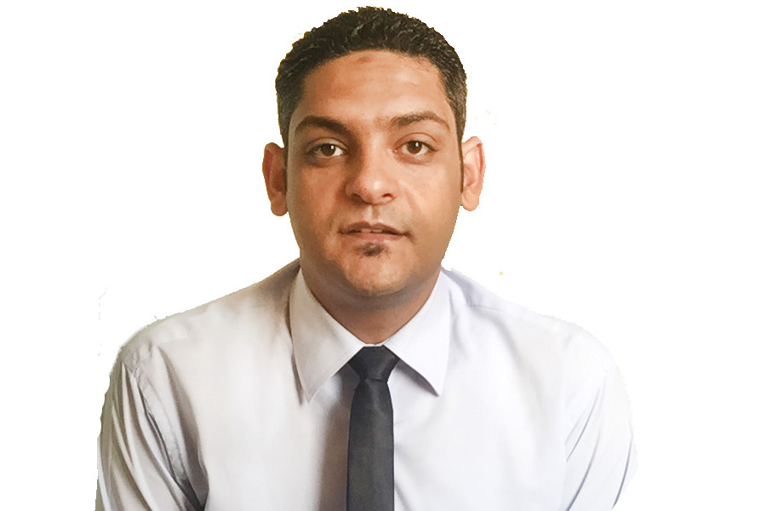

Ahmed
Ahmed.372678@2freemail.com

OBJECTIVE:-

A Committed, diligent and proactive person, excellent team player with the ability to motive people, follow up as well as provide leadership, natural flair for effective communication ,Strong interpersonal skills and ability to take initiative, makes suitable for Accountant , Banker , customer service , Teller , receptionist or any position fits with my qualifications.

QUALIFICATIONS:-

Bachelor Degree in Commerce (Major Accounting) - Alexandria University, Egypt 2011

WORKING EXPERIENCE:-

Ream Real Estate co. March , 2017 till now
General Accountant
Reason of leaving : company sold their properties .

KEY RESULT AREAS & RESPONSIBILITY:-

• prepare financial records and reports for a variety of real estate transactions
• Reports for property sales, rentals, leases and time-sharing.
• provide investment analysis and planning for organizations seeking to acquire and develop property .
• Follow up with all tenant regarding late payments and the ending contracts .
• Dealing with banks about all cheques and due to amounts .
• Communicating with head office and update them with the reports for all maintenance contracts with the company .
• Opening new contracts for living ( personal ) or investments ( commercial ) .
• Communicating with lawyer office regarding returned cheques from the bank and all pending cases in court .
• Collect the payments ( RENT ) from the tenant .
• Responsible for petty cash and all invoices for the maintenance .
• Holding safe keys .
• Using online system ( Citrix )

Redha Al Ansari Exchange Dubai, UAE April 2013 till January 2015

Teller, Cashier and sales for all the productions

Redha Al Ansari Exchange Dubai, UAE January 2015 till March 2017

Supervisor & compliance officer

KEY RESULT AREAS & RESPONSIBILITY:-

*Customer service and call center agent .
*Attend all the calls and handling all the issues in the branch .
* Sales for all the productions and marketing .
* Cross selling .
*Monitors and revises policies and procedures for the general operation.
* researching and resolving audit issues
* Preparing the end of day reports.
*Process all kind of transaction to all banks & Exchanges in different countries such as
Egypt – India – Bangladesh – Nepal – Philippines – Gulf Countries – Jordan – Yemen –
Lebanon – USA – Europe.
* Great knowledge with Instant Cash & Western Union transactions.
* Dealing with AIR ARABIA & FLY DUBAI payment.
* National Bond Registration and Payment.
* Making final reports for ending shift.
* Great experience in dealing with cash.
* Preparation of various reports for senior managers.

APEX Company for Diesel Generators Egypt January 2012 to April 2013
Accountant and sales for the generators production

KEY RESULT AREAS & RESPONSIBILITY:-

- Maintenance of fixed asset register. Maintenance of Cheques.
- Handling Clients. Preparation of Bills. Office Management.
- Bank reconciliation and other accounts reconciliations.
- Keeping Track of Payroll. Preparation of Quotations.
- Book keeping and recording the accounting entries.
- Handling Accounts Payables / Accounts Receivables.
- Handling and e-filing of software programs, etc.
- Projection and Implementation of Plans.

PERSONAL STRENGTHS:-

Good interpersonal skills. Highly trustworthy, discreet and ethical.
Strong ability to work effectively with multiple supervisors.
Excellent written and verbal communication skills.
Dedicated to maintain high quality standards.
Strong in leadership & human relations.
Accountancy and budget management
Customer service techniques
Customer services ethics
Staff management
General office management
Flexible and adaptable
Attention to details
Ability to make decisions and take appropriate actions
Ability to learn more in short term and ready to be training for any system

COMPUTER SKILLS:-

Microsoft Excel, Word & Email
Microsoft Windows 2007 and Microsoft Office 2008 Operating Systems.
Peachtree program
Visual Finwin program
Amadeus system

LANGUAGES:

Arabic (Native)
English (Excellent in spoken and written)
Reference upon request

