CURRICULAM VITAE

BIBIN 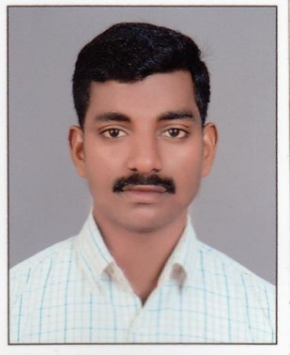 BIBIN.372690@2freemail.com

Career Objective:

To equip myself as a successful professional that provides me opportunities to exploit my knowledge and extensive development skills to the extreme levels of my ability and to continually upgrade myself to the highest levels of expertise enabling the organization to achieve its target and growth.
Employment History:

B.Harikumar & Associates, Chartered accountant firm :-( March-2014-June 2017 )

- Processing payments to the Consultant, Contractors, Sub contractor and other Vendors.
- Issuing, authorizing & maintaining petty cash for the Department.
- Preparation of Reconciliation statements – Bank A/c, suppliers A/c and Inter Branch.
- Property wise monthly allocation of maintenance expenses and prepaid expenses.
- Assisting in the preparation of monthly financials, Budget, Income-Expense.
- Coordinating with banking department for funds for related parties.
- Processing payments to the suppliers of services based on approved invoices and LPO’s.
- Payroll – Preparing salary, leave salary, overtime, and full and final settlement of employees.
- Keeping track of Post Dated Cheques issued.
- Bank Reconciliations and handling issues relates to Bank.
- Management of Parties (Debtors & Creditors), Ageing analysis
- Management of funds (cash & Bank)
- Petty cash handling , and closing of petty cash accounts
- Help the senior accountant to the daily routine works
- To Control all the expenses and encourage the subordinates

Educational Qualification:
Academic Qualification:

- Master of Commerce (MK university, Tamilnadu)
- Bachelor of Commerce.(University of Kerala)
- Plus two (Vocational Higher Secondary Education, Government of Kerala)
- SSLC (Government of Kerala)

Computer proficiency:

- Diploma in Computerized Accounting.
- MS Office.
- Tally ERP 9.

Communication skills:

- Spoken: English, Malayalam & Tamil.
- Written: English, Malayalam

Strengths:

    - Ability to work on Initiative and handle Work Confidentially.
    - Hardworking, Sincere and trustworthy.
    - Team Player.

I hereby declare that the above information is true and correct to the best of my knowledge and belief.

