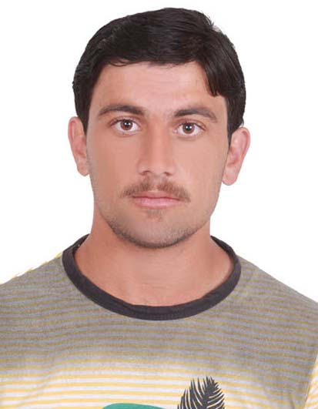
Waqar Khan
Personal Information

- Date of Birth March, 16, 1992
- Nationality Pakistani
- Marital Status Single
- Visa Status Employee
- Valid UAE driving license

OBJECTIVE:
To establish myself as a professional seeking a challenging job in a stimulating work Culture and to work devotedly in a dynamic and an innovative environment, and to utilize my knowledge & strength to expand my exposure while serving in one of the best organization to establish long term relations with it.
Qualification
- Bachelor of Science (Hons) Agriculture (2011-2015) The University of Swabi Khyber Pakhtunkhwa-Pakistan
Professional Experience and Projects
- Working as a Site Engineer at Mahraj Groups of Companies Dubai, UAE from March 2016 to till date
Major Responsibilities:
- Plan and schedule the works and efficiently organize the site/facilities in order to meet client requirements for events management, landscaping construction and building maintenance works.
- Supervises and monitor the site labor force through Supervisors/Foreman; for all landscape construction, Events management and building maintenance from shop drawing till hand over.
- Prepares necessary paperwork for the completion of work and get it authorized by consultant.
- Coordinate of teams as per program requirements.
- To identify, coordinate procurement of materials as per program requirements.
- Oversees the requisition of material for use in the construction maintenance and check whether the materials are specified.

Projects

- Worked as Company representative and client coordinator at following different platforms and projects :
- Yas Marina Circuit for F1 Formula Race Yas Marina Circuit Abu Dhabi
- New Year Celebration Fireworks (Downtown, Burj Khalifa, Burj Park. Dubai)
- New year celebration Fireworks in Al Maryah Island (Ras al Khaimah)
- Emirates Classic Car Show ( Downtown Dubai )
- Gulf Car Festival Business Bay Dubai.
- Red Bull Air show Abu Dhabi, Red Bull Car Drifting Maydan Dubai
- Dubai mall Project, ( Building and Electrical Maintenance)
- Dubai, Abu Dhabi and Sharjah Electric Run.
- DU Arena, Du Forum Abu Dhabi
Experience
- SSG Landscaping & Swimming Pools Islamabad
Landscape Designing, Plant Nursery gardening, irrigation installation & Designing
- Worked as internee at "National Agricultural Research Center Islamabad" on Quality Evaluation of Wheat Flour for the following aspects;
- Moisture determination
- Ash determination
- Crude fiber determination
- Fat determination & Protein Determination
- Three Months Experience certificate (National Agricultural Research Center Islamabad)
- 2 Month experience at sunny international Peshawar
- Quality assurance of fruit and vegetable
- Grading of fruit and vegetable
- Sorting of fruit and vegetable
- Packing of fruit and vegetable
Computer and Other Skills
- Window 7 and Window 8
- M.S Office (MS Word, MS Excel, MS Power Point) and good command in English Language & internet skill usage.
- Excellent Analytical, Communication & Interpersonal skill, Window & Internet surfing.
Reference
- Will be furnished on Demand

