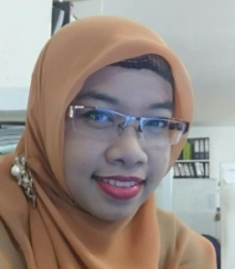
SUMMARY

I Have 5 years experience as General Administration Project in Interior design Company.
I have skill and experience in planning, detailing, and coordinating about production
process in the factory. My excellent communication, problem solving and

PERSONAL DATA
- Nationality : Indonesia
- Birth of Place : Blitar
- Birth of date : 1st, March 1982
- Gender: Female
- Marital Status : Marriage

COMPUTER SKILL
- MS. OFFICE
- AUTOCAD 2D
- MS. PROJECT
- SKETCH UP
- CORELL DRAW

leader ship skill, combined with my deep knowledge of engineering and
architectural codes make me a highly valuable and team leader.

EDUCATION
- MALANG NATIONAL TECHNOLOGY OF INSTITUTE (INDONESIA)
Bachelor of Architecture
Graduated 2005
GPA 3.07
- MALANG SCHOOL OF BUSSINES
Proffession of Graphic Design
Graduated 2001
GPA 3.42
- SENIOR HIGH SCHOOL
SMAN 1 BLITAR
Graduated 2000

WORK EXPERIENCE

- Start from Nov 2012 to june 2017 Present GENERAL ADMINISTRATION PROJECT
AT PT. KURNIA NATA KENCANA INTERIOR DESIGN COMPANY AND
MANUFACTURE BRAND OF METRIC KITCHENSET BY SIDOARJO JAWA TIMUR
INDONESIA
RESPONSIBILITIES :
- Accept n check the document contract from Marketing before production
process, Negotiation with marketing about schedule of production time
- Review all of items that necessery before the next production process
- Give information about Detail Order to logistic division and purchasing divison.
- Manage about all of document contract to Technic corector
- Estimate about some items /parts specification of product
- Give information/up date schedule to instalation division

- 2007 – 2008 AS ASSISTANT of ARCHITECT in PALM OILTREES COMPANY PT. TUNAS PRIMA SEJAHTERA AREAL KUTAI KARTANEGARA KALIMANTAN TIMUR
RESPONSIBILITIES :
- Assist in the coordination of plans and design
- Helped to monitor the flow development activities to ensure completion of architectural work for new construction project
- Conducted studies a special project n space planning, structural analysis design, feasibility and other related architectural engineeing issues
- Supported and assisted lead architect in all phase of a major project
- Performed and array administrative duties related to arhitectural construction projects such as code and zoning research , reviewing contractor forpayments and utility bills, monitoring projects budget and coordinary utilities instalation.

