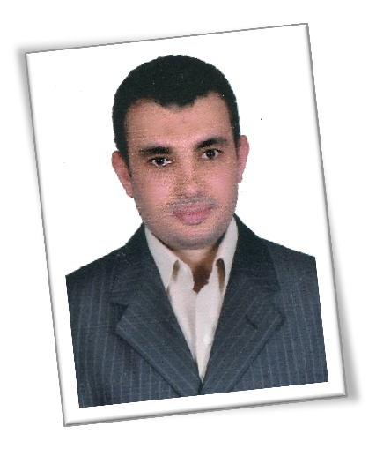

Member in Egyptian Engineering Syndicate

Deep Knowledge
- Pneumatic and Hydraulic systems.
- Contactors, Relays, Solid state relays, Timers, Counters, Overloads, Encoders, Temperature controllers, PLC's, Cables, Circuit breakers, Fuses, Sensors, Switches, Proximity, Photocell, load cell, Pressure transducer, Flow meter, Control valve and Measuring instruments
.
- Air – Compressors, Driers, Industrial Water Chillers and steam boilers.
- Electronic Boards. "Design, troubleshooting and Implementation".
- Light Current.
- Low Voltage "transformers, switchgears, ATS, power factor correction, distribution panels and Generators"
- Servo and DC Motors Drive.
Wael wael.372703@2freemail.com
ELECTRICAL CONTROL ENGINEER

Career objective
To contribute relevant experiences and education background to my working field and to join a company that offers me a stable and positive atmosphere and inspires me to enhance and therefore to
innovate the work culture for the betterment of all parties concerned. I can work effectively in hazardous and sterile areas.

Work Experience

Senior control and electrical maintenance engineer "Crew maintenance manager" from 2002 in till 2014
, 10th of Ramadan city, Egypt.
  - Supervise the maintenance activity (Preventive and Predictive Maintenance), from electrical and electronic prospective based on the PM Master schedule.
  - Outlines maintenance procedures for electrical & automated systems/equipment to ensure maximum service life and utilization.
  - Reviewing the equipment daily log sheets as well as the weekly and monthly PM sheets.
  - Participate with preparing for the budget for all electrical and process automation activities.
  - Supervision the operation of the utilities equipment.
  - Supervision of the instrument calibration based on the calibration master list.
  - Manage and develop the maintenance staff.
  - Create and implement local EHS programs.
  - Execute the computer system validation/ remediation activities for the facility automated systems.
  - Plan for the new projects.
  - Manage new project until delivered to owner.
  - Find solution for any equipment “Electrical & Mechanical” problems and act as troubleshooter in case of production stoppage.

Private Business " Electrical supply project " from 2014 in till 2017

Experienced in
  - Field Instrumentations (Control Valves, Pressure Transducers, Flow Meters, Temperature Controllers, fluid regulators and Metering).
  - Handling systems and conveyors.
  - Design Electrical Control Panels.
  - Injecting Machines Plastic Extruders and Thermo forming machines.
  - Control circuits, power circuits, troubleshooting and maintenance.

    - Programmable Logic controller (PLC’s)" Delta, SIEMENS S7(200- 300), SIEMENS S5 and has ability to understanding any other type of PLC in a few days.

Personal Skills
- Effectively participating in group discussion.
- Creative, dynamic and challenging.
- Dynamic, confident and self- motivated personality.
- Good Communication skills.
- Effectively working in a team environment.
- Effectively managing time and stress.
- Organizing and presenting ideas effectively.
- Leadership personality.
- Combine between practical experience and academic background.
- Eager to Learn and Discipline.

Personal information
- Nationality : Egyptian ü Birth date : 4/4/1979 ü Marital Status : Married ü Military Status : Exempted ü Driving license : Yes
    - AC Motors drives (Inverters) types as (SIEMENS, MITSUBISHI, Parker, LG, Fuji, Eurotherm, and Altivar).
    - Dc motor drives (Converters) type as SIEMENS.
    - Industrial Communications Systems "Profibus, Canbus, AS-interface, RS232, RS485 and MPI.

Education

Bachelor of Engineering Electrical - Bio medical engineering
Al- Shorouk Academy 2001 Grade Good
Graduation project Incubator for infinity Grade Excellent

Technical Summary

Continually learning, developing and upgrading my skills and increasing my knowledge through effective training & development programs.
- Certification from industrial systems company (10th of Ramadan) in Fatek PLC,*easy view*, HMI, and SCADA system.
- Certification from National Panasonic for communication systems in CCTV, Fire alarm system and Firefighting system.
- Certification from Auto Technology company in PLC Siemens SIMATIC step 7 programming (Level I – II) course.
- Training in KONOZ company in maintenance of electronic cards and revere engineering.

Computer Skills
- Proficient in windows environment.
- Experienced in using a number of packages such as MS Office.
- Proficient internet user.
- Have a good knowledge in computer hardware.
- Have a good knowledge in some of programming languages such as Visual Basic (programs implementation)

Availability : I'm able to start work after 4 weeks from announcement. Rank : Senior.
Job field : Industrial Engineering, Control Engineering, Instrumentation, Automation, Planning and Project Management
Job location : Egypt - Arab Countries Salary : As the Company determines.
All documents are available upon request

