VIGNESH
VIGNESH.372705@2freemail.com 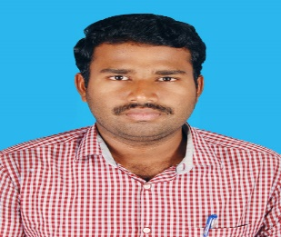
CAREER OBJECTIVE

A highly professional and dedicated Civil Engineer to achieve high career growth through continuous process of learning for achieving goal & keeping myself dynamic in the changing scenario to become a successful professional and leading to best opportunity And am willing to work as a Junior Site Engineer Cum QS in the reputed construction industry.

PROFESSIONAL PROFILE
- Site supervision/execution for civil construction work and ensure that the work is as per the project specifications and issued for construction drawings/final approved drawings from authorities.
- Preparation of BOQ for civil works. BBS for structural elements
- Proper management on workmanship.
- Monitoring daily progress of site.
- Preparing weekly and monthly progress report to be submitted to the project director and consultants.
- Coordinate with subcontractors for smooth flow of work.
- Preparing running Account bills
- AutoCAD drafting 2D (2007, 2010, 2013) and STADD PRO.
- Inspecting and testing materials prior to their use at site as per sample approved by the consultant and ensuring removal of rejected material out from site.
- Maintaining the safety parameters.
- Making productive report and analyzing.
- Ensuring that all work is done without wastage of material.
WORK EXPERIENCE - 2 years in civil construction

Company : SAS EPC SOLUTION PVT LTD, INDIA
Period : September-2015 to September 2017
Designation : Junior Site Engineer Cum Qs
Major Project : Hydro Power Project (SARSUMA MHS - 3.25 X 3 MW)

PROFESSIONAL EXPERIENCE
- Site marking and levelling for every elevations of the project.
- Inspection of material quality and work.
- Preparation of drawings for special shuttering fabrication.
- Checking of running bill account for contractors.
- Preparation of weekly progress report for project..
- Planning of day to day and weekly work activities in the project.
- Cost reduction in the project work.
- Preparation of BBS
- Prepare the bill for weekly labour payment.
- Maintaining the safety standards and parameters as per guidelines.
- Completion of work before the project schedule.

AREA OF INTEREST
- Site execution
- Quality control
- Quantity surveyor

ACADEMIC QUALIFICATION

June 2011 – May 2015 Dhanalakshmi College of Engineering, Chennai, India.
Bachelor of Civil Engineering (B.E)-63%
June 2009 – March 2011 Rotary Club Matriculation Higher Secondary School,
Tamil Nadu, India
Higher Secondary Certificate (HSC)-78.2%
March 2009 Raj Higher Secondary School, Tamil Nadu, India
Secondary School Leaving Certificate (SSLC)-71%

PERSONAL DETAILS

Date of Birth: 7th March 1994
Nationality: Indian
Language proficiency Tamil. English, Hindi

I hereby declare that the information provided above are best of my knowledge.

