CURRICULUM VITAE

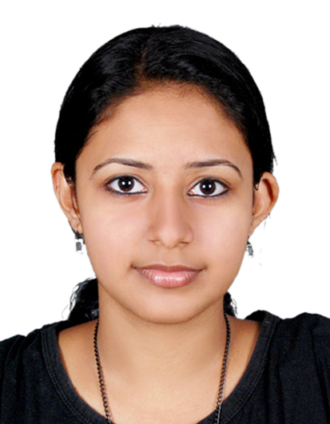
Dr. Nimisha
Nimisha.372718@2freemail.com
(Certified Medical coder)

OBJECTIVE

I would like to work for your organization as an asset and to explore my knowledge and experience of working in the most competent environment where I can give full potential and skills for the best of my organizational interest.

QUALIFICATION

- Bachelor of Homeopathic Medicine & Surgery (BHMS) ,2016
Institute- Dr.Padiar Memorial homeopathic Medical College chottanikkara
University- Kerala University of Health Sciences.

- Certified professional coder (CPC-A) from AAPC (American Association of professional coders) with 90%. (Member ID: 01538140)

- HSC
(Vimalagiri CBSE Public School ,Kothamangalam)

- SSLC
(Mahathma Gandhi CBSE Public School ,Chottanikkara)

PROFESSIONAL EXPERIENCE

Worked as Doctor in Chettiankunnel Clinic, Piravom, India, Jul 2016 — June 2017

EXPERIENCE (INTENSHIP)

Worked as an Intern in Dr.Padiar Memorial homeopathic Medical College chottanikkara from July 2015- July 2016.

TRAINING PROGRAMME

Attained three months training programme in Medical Coding And Billing (April 2017- June 2017) from Aldos Institute of coding and Billing, KOCHI,KERALA,INDIA

ROLES AND RESPONSIBILITIES

- Extremely knowledgeable with regard to Medical coding guidelines and coding techniques (ICD-10-CM).
- Expertise in reviewing and assigning accurate medical codes for diagnoses, procedures and services performed by physicians and other qualified healthcare providers in the office or facility setting.

- Strong familiarity with coding related to evaluation and management, anesthesia, surgery, radiology, pathology and medicine.

- A sound knowledge of medical coding guidelines and regulations including compliance and reimbursement-allowing to better handling issues such as medical necessity, claims denials, bundling issues, and charge capture.

- Knowledge of anatomy, physiology and medical terminology necessary to correctly code provider diagnosis and services.

- Possessing a responsible attitude, tact, patience and courtesy.

- Ability to operate under pressure and deliver to demanding deadlines

- Strong verbal and written communication skills.

- Profound therapeutic and clinical knowledge

- Excellent ability to evaluate symptoms in context of patient history

- Eager on updating knowledge and learning more about the latest developments in medical science.

- Thorough knowledge of medical laws and ethical standards of medical care.

RESPONSIBILITIES HANDLED AS INTERN.

- Assisting the senior doctor in checking the patients.
- Diagnosing the disease as per the symptoms.
- Learning the diagnostic methods.
- Periodically meeting the patients and observing their improvements and making reports.
- Helping other medical staff in performing their duties
- Provided First Aid to the patients who come in with injuries following accidents.
- Accompanied the medical practitioners during their visits to medical camps and awareness workshops

KEY SKILLS

- Sound knowledge of Medical terminology.
- Good verbal and written communication skills.

- Punctual.
- Disciplined
- Typing speed
- Highly motivated
- Positive thinking
- Fast Learner
- Leadership Abilities
- Yearn for Knowledge
COMPUTER LITERATE
Can work effectively with the following computer applications,
- Operating system: Windows XP,7, 8,10

- Microsoft Windows for Word

- Microsoft Windows for Excel.

- Microsoft Windows for Power Point
ACADEMIC PROJECT

- Thesis - Management of type 2 Diabetes with Homoeopathy.
- Drug proving.

MY STRENGTHS

- Excellent theoretical knowledge.
- Good Knowledge of Clinical practices and protocols.
- Excellent team player and interpersonal skills.
- Commitment towards work, dedication and integrity.
- Smart and efficient working
- Openness and positive attitude.
- Excellent and fluent communication skills.
PERSONAL DETAILS

- Date of Birth: 11-December-1991
- Marital Status: Married
- Religion : Christian
- Nationality: Indian
- Current visa: Visit

DECLARATION

I, hereby declare that the above mentioned details are true, to the best of my knowledge and belief.

