Mohamed
Mohamed.372747@2freemail.com

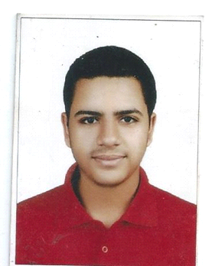
PersonalInformation:

Date of Birth : 01/09/1994
Place of Birth : Cairo
Marital Status : single
Nationality : Egyptian

Objective:
looking for an opportunity to join your honored company , to increase my skills, to develop my field experience in the actual field life, to enhance my communication skillswith, customersand workers .
Academic Qualification:
Secondary Emirati Education
Degree: 89.9 %
Year : 2012

Studied for 3 years in Factualy of commerce in Cairo Univeresity but not complete

Language Skills:
English : good (written and spoken)
Arabic : mother tongue.

Computer skills:
Microsoft office: Good (word, excel, and power point).
Internet skills: excellent

- Note : I have Emirates driving license (Automatic )
- Career experience:
- 1 – Worked as secretary (sending & receiving emails and contacting with customers & Suppliers , making invoices & data entry ) for 4 years in golden tape industries in Dubai
- 2- worked as sales man for 2 year at golden tape industries in Dubai
- 3- worked for 3 years as Representative ( documents clearance at governmental entity)
- 4- worked as supervisor for 1 year at Mushroom resturant in Egypt
- Soft skills:
- Self learning
- Communication skills.
- Leadership skills.
- Presentation skills.
- Working under pressure.
- Time management.
- Problem solving.

Thanks and I will do my best to get the trust

