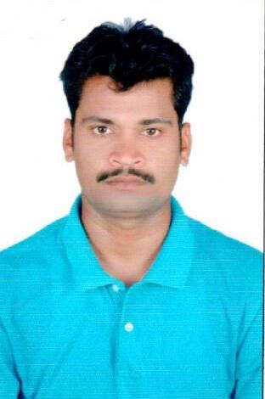

GAUTAM
GAUTAM.372755@2freemail.com

POST APPLIED FOR “ELECTRICAL & INSTRUMENT FO”

PROFILE

A Suitable position with an organization where I can utilize the best of my skills and abilities that fit to my education, skills and experience a place where an encourage and permitted to be an active participant as well vital contribute on development of the company.

SKILLS

Very Energetic result oriented and organized.
Have a high respect for customer’s service.
Courageous true towards the duties.
Always keep on smiling under pressure.
Efficient and well behaved person.
Extremely hardworking self motivated and able to work independently.
Keep excellent inter personal relations with colleagues and ready to help them.

EDUCATIONAL QUALIFICATION
Higher Secondary School Certificate.

PROFESSIONAL QUALIFICATION

I.T.I in Electrical Trade From CTS MTH & Training Institute India. (2006)

WORK EXPERIENCE:
I have total 9 years of experience, 3 years for UAE, and 06 years for India as I
mentioned below,

WORK EXPERIENCE

Presently working as a “Electrical & Instrument Foreman” in PLQC LLC,
in Dubai UAE, since 23rd Aug 2014 to till date.
Worked as a “Electrical & Instrument Foreman” with ITPCL Cuddalore (Tamil Nadu) C/O Iot Engineering Project Ltd, from 12th Oct 2013 to 06th Jul 2014.

Worked as a “Electrical & Instrument Foreman” with Technimont ICB Pvt Ltd–Borouge-Iii Project, Abudhabi.UAE, from 22nd Jul 2012 to 18th Jul
2013.

Worked as a “Electrical & Instrument Foreman” with IOT Engineering Project Ltd. Aiil 2x660mw (Kawai) (Rajasthan.), from 18th Apr 2012 to 2nd Jul 2012.

Worked as a “Electrical & Instrument Foreman” with IOT Engineering Project Ltd. Mahatma Gandhi Thermal Power Project, Jhajjar Site, Haryana, from 11th Aug 2010 to 25th Jan 2012.

Worked as a “Electrician” with IOT Engineering Project Ltd. Iocl Refinery, Pncp Site, Cpp, L&T Site, Haryana., from 19th Sep 2008 to 16th Jun 2010.

Worked as a “Electrician” with IOT Engineering Project Ltd. Iocl Refinery, Pncp Site, Offsite, Haryana., from 26th May 2008 to 22nd Aug 2008.

Worked as a “Electrician” with Petron Engineering Construction Ltd , RPL Site, Jamnagar Gujarat, India, from 10th May 2007 to 15th May 2008.

Worked as a “Electrician” with Petron Engineering Construction Ltd ,Acc
Site, Tikaria (Up) India, from 15th Dec 2006 to 30th Mar 2007.

PERSONAL DETAILS
Nationality : Indian
Date of Birth : 01st Jan, 1985
Gender : Male
Religion : Hindu
Marital Status : Married
Language Known : English & Hindi.

DECLARATION
I hereby certify that the above information are true and correct according to the best of my knowledge & My Experience.

