CURRICULUM VITAE

ANIL
ANIL.372824@2freemail.com
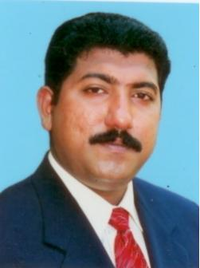

PERSONAL DATA
Name Mr. ANIL
Date of Birth 30-11-1978
Marital Status Married
Nationality Indian
Religion Christian
Mother Tongue Malayalam
Language Known English, Hindi, Tamil

ACADEMIC QUALIFICATIONS

 | Institution | Board/ University | Year of Passing
SSLC | Metropolitan High School, Puthencavu, Chengannur,Kerala | Board of Public Examination | 1994
Pre-Degree | Christian College, Chengannur, Kerala | Kerala University | 1997
Degree in Commerce | Private Study | Mahatma Gandhi University | Course completed on 2000

Computer Qualifications

Knowledge in DESO(data entry and software operations) passed from L.B.S Kollakadavu, Kerala, India on the year 1996, and Degree in Computer Software Applications (including the experience in M.S.Office) which was passed on the year 1997 from ET&T computer education and training center, Chengannur, Kerala, India.

WORK EXPERIENCE IN UAE

Designation | Name of the Company | Year of Experience
Office managing - Data entering, preparation of invoices, petty cash controlling & office documentation. Operational assistant of purchasing, repairing section of the automotives, Ware house supervising. Team leader of managing the employees of 30 numbers | Golden water supplying LLC - Ajman | 2003-2007
Salesman (for the diary and fresh juice products) | Al Rawabi Diary co: LLC - Dubai | 2008-2010
Sales Executive(for packing materials) | World pack LLC - Sharjah | 2011-2014

Holder of valid U.A.E Driving License (Light Vehicle)
License issued date: 06-08-2006 - Expiry date: 13-11-2026

STRENGTH
- Adaptability to various situation
- Well planned and more organized
- Good authority power
- Creativity
- Patience
- Good team player

HOBBIES
- Traveling
- Hearing music
- Reading

FUNCTIONAL STYLE
Versatile soft spoken and highly motivates possess excellent interpersonal skills. Genuinely interest in the growth of people and the team thrives in an environment challenge sincere and principled organizational goals receding personal interest.

PERSONAL PROFILE
Born on 30th November 1978 has been brought up in an atmosphere laying strong emphasis self disciplined and self-reliance.

DECLARATION
I here by declare that the information furnished above is true to the best of my knowledge. I will do my very best if I placed in your esteemed company.

