Deepthi.372867@2freemail.com

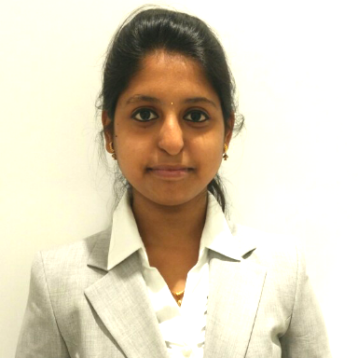

DEEPTHI
(Senior Analyst–Accounts payable)

BASIC INFORMATION

Nationality: Indian
Father Name:Venugopal C
Gender : Female
Civil Status :Single
PassportNo :J6949565
COMPUTER SKILLS

- MSWord
- Excel
- Power Point

CONTACT INFORMATION

PROFILE

Masters in Business Administration – Finance. Senior Analyst– Finance Accounts Payable in Flextronics India Pvt Ltd. Single point of contact globally, to the focal list of suppliers, ensuring the suppliers are managed and maintained in current, with necessary coordination in place across AR team, GL team, Payment team, buyers and site treasury in terms of all the requirements of the supplier
WORK EXPERIENCE(2.5 Years)
November 10, 2014 – Till date —Working in Finance Accounts Payable as a Senior Analyst

KEY SKILS
(2.5 Years)
- Accounting/Finance: Extremely focused on the job, keep track of each and every aspect, apply my strong fundamental knowledge and update continuously
- Problem Solving: Resolves in-depth queries in a methodical manner independently and with internal and external business partners to find appropriate resolutions and efficiencies.
- Proactive: Ability to identify (well in advance) where and when a problem can arise; exceptional troubleshooting skills aided by presence of mind
TOOLS KNOWN

- ERP: BAAN, TALLY ERP9.
- Front End Tool: Optika (Work Flow), and single interface web based tool TITAN
- Working Platforms: MS-word, MS-Excel
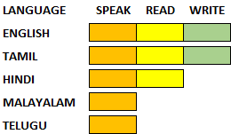
LANGUAGE KNOWN

PROFESSIONAL EXPERIENCE

Flex India Pvt Ltd, Chennai, India Nov 2014 – till date

Flex Ltd. (previously known as Flextronics International Ltd. or Flextronics) is an American multinational technological manufacturer. It is the third[2] largest global electronics manufacturing services (EMS), original design manufacturer (ODM) company by revenue, behind only Taiwan's Pegatron to original equipment manufacturers (OEMs).
Flex is headquartered in Singapore and has manufacturing operations in over 40 countries, totaling approximately 200,000 employees.

Senior Analyst – Accounts Payable

Business s

- Department: Finance – Accounts Payable
- Maintain and processing of invoices for more than 150+ supplier
- Involved in reconciliation of incoming and outgoing transactions on daily basis
- Encouraging and implementing continuous Accounts Payable improvement
- Measures on day-to-day basis with in the area of responsibility
- Ensure that the inflows of documents are processed
- Involved in the Process of handling Vendor Queries

Roles & Responsibility

- Processing PO and NON-PO invoices for Europe region for Hungarian site which are coming into the workflow and then process for payment
- Verify that transactions comply with financial policies and procedures
- Communicating to buyers, vendors and the site finance team in order to resolve the blocked Invoices
- Performing SOX 80% reconciliations for Third Party Suppliers for Every Half Year
- Training the new employees and coaching the existing team
- Sending Monthly Productivity reports to sites
- Handling mail queries from the suppliers and responding within the time lines
- Ensure to receive on time Statement of Accounts from suppliers for reconciling
- Updating the status of the invoices of the suppliers with their payment dates
- Identifying the errors in invoices and reporting to the concerned persons and ensure that rectification has been done while performing reconciliation

Achievements

Pat on the back Award within the joining of 3months for learning the process quickly

THANX Award for Learning the NON-PO Hungary process quickly and Booking the invoices without single error highlighted in last 2 quarters

EDUCATIONAL QUALIFICATION

Master of Business Administration (Finance) – (Jun 2015- 2017)
Pondicherry University, Chennai.

Bachelor of Commerce in Accounting and Finance – (Jun2011 - 2014)
Anna Adarsh College for women, Chennai.

PERSONALITY TRAITS

- Friendly to each and every one and target oriented in work pursue, Assertive in taking decisions & Quick learner with good communication and Interpreting Skills
- Self-Confident and Creative Thinking.Good co-ordination and co-operation with the team
- Possess good communication / inter-personal skills
- Adaptable to diversified work environment
- Good learner and good performer both in team and independent environment
- Self-driven personality coupled with problem solving attitude

DECLARATION

I hereby declare that the above mentioned information are true to the best of my knowledge.

Place:Chennai

Date:
PlPl Yours truly,

(Deepthi V )

