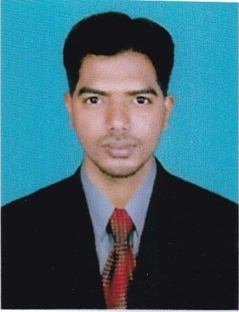
CURRICULUM VITAE
ABDUL
ABDUL.372877@2freemail.com

Career Objective
To have a growth oriented and challenging career , where I can contribute my knowledge and skills to the organisation and enhance my experience though continuous learning and teamwork
Academic qualification:
- B.E (Mechanical Engineering) from Sri Angalamman College of Engineering and Technology with 6.5cgpa in 2015 at Trichy.
- DAE (Automobile Engineering) from Sirinivasan Polytechnic College with 85% in 2012 at Perambalur.
- HSC inGoverment Higher Secondary School with 64% in 2010 at Ariyalur.
- SSLC in C.S.I Higher Secondary School with 60% in 2008 at Ariyalur.
Work Experience:
I have worked in Ultra tech cement factory for 2year.I am worked as Supervisor in the company.It is the Special Purpose maintenance and fabrication company.
Software proficiency:
- Basic knowledge of Auto-cad
- Basic knowledge PRO-E
- Basic knowledge of COMPUTER
Area of Interest:
- Manufacturing Technology
- Maintenance working
Mini Project:
Project name; DESIGN AND FABRICATION OF AUTOMATIC LATHE COOLANT PUMP
Abstract; Automatic cooling unit is a system typically delivers a controlled amount of coolant to specific locations on a machine while the machine is operating, at specific times from a central location. when temperature at the work piece is increased above reference temperature, the automatic coolant unit will activate and automatically pumps coolant and will reduce the temperature.
Main project
Project name; AUTOMATED GUIDED VEHICLE AND REMOTE CONTROL
Abstract; The implementation and experimental results of a Radio Frequantcy (RF) based wireless control of distributed peripheral interface controller (PIC) microcontroller based Automated Guided Vehicle(AGV), which is known as ROVER (Roaming Vehicle for Entity Relocation).
Introduction; Wireless communications now a days is becoming increasingly popular for factory and process control automation system. Part of this growth is due to the emergence of very reliable radio frequency technologies capable of handing the extreme conditions present in industrial plant.
Industrial visit
Neyveli Lignite this is Asia’s largest open mine. This is well known as neyveli liginite corporation (NLC)40% of tamilnadus power production.
Co- curricular activity
- Have completed Fire&Safety training
Personal Trait:
- Creative and logical
- Problem solving ability
- Co-operative and keen observer
Extra curricular activities:
- Participated in outer college hockey match (Runner).
- Participated in outer college paper presentation in designing.
Personal details:
Date of birth : 22 March 1993
Languages known: English and Tamil, Hindi
Gender : Male.
Marital status : Single
Natioality : Indian.

Declaration:
I here by declare that all the details furnished here are true to the best of my knowledge .

