CURRICULAM VITAE  MOHAMMED  Email : MOHAMMED.372885@2freemail.com  Objectives: | 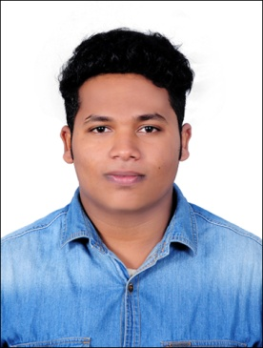

To Secure A Challenging Position In The Field Of this Industry That Offers Professional Growth While Being Resourceful, Innovative And Flexible. To Be A Part Of A Dynamic, Progressive And Learning Organization, For Enrichment In Terms Of Input And Provide Ample Scope For Employing My Abilities And Knowledge , To Achieve Excellent Results And Be A Strong Pillar Of The Organization

Academic Profile:

- 3Ds Max, V-ray, AutoCAD and Photoshop

Educational Profile
- S.S.L.C (BOARD OF PUBLIC EXAMINATION, KERALA)
- PLUS TWO (BOARD OF HSE KERALA)
- DRAUGHTSMAN CIVIL FROM MARKAZ ITI ATHAVANAD (NCVT)

Computer Skills:
- AutoCAD 2D
- 3D Studio Max Modeling
- MS Office
- Internet
- Adobe Photoshop

Language Known:
- English, Malayalam, (Spoken, Reading and Writing)
- Hindi , Arabic (Reading and Writing)

Request for Suitable Post:
- 3D Designer, Autocad Draftsman
- From NOV 2015 to JUN 2017 : DH ASSOCIATES,VALANCHERY

Personal Details:
- Nationality : Indian
- Date of Birth : 26-01-1996
- Sex : Male.
- Marital Status : Single

Declaration:
I hereby declare that all the above furnished details are true and correct to the best of my knowledge and belief.

