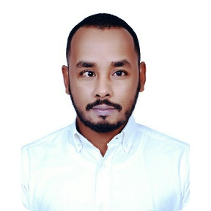
Khalid
Khalid.372892@2freemail.com

Career Objective:
Seeking a challenging position in a reputable company where my academic background and interpersonal skills are well developed and utilized.

EXPERIENCE SUMMARY

Hyundai Arabia HHI, LLC, Saudi Arabia (Jan 2016 – Apr 2017)
Working as IT Support Engineer providing technical assistance and support related to computer systems, hardware or software. Responsible for providing efficient customer support for both 1st & 2nd Line issues relating to Network, Desktops, Servers, Laptops and peripherals. Supporting over 200 users & and handling all IT tickets.
Duties:
• Serve as the first point of contact for customers seeking technical assistance over the phone or email through tickets. Monitor and respond quickly and effectively to requests received through the IT helpdesk ticketing system.
• Resolving the incidents successfully with the proper solution in timely manner with in SLA.
• Provide helpdesk Technical support and resolve problems to the end user's satisfaction
• Diagnosing and resolving a wide range of technical issues over the phone. Answering & responding to all calls & requests within agreed time scales (SLA)
• Providing complete technical support over remotely or personally to all IT users for various issues such as windows issues, printer, network, outlook, password, login, application, antivirus, software update, domain issues, etc.
• Installation of OS, application software, deployment of software, disk quota management, installation and configuration of hardware devices, managing system updates and printers, working with domain accounts, local accounts, network shares and permissions, restoring data and scheduling backups, system failure troubleshooting, monitoring performance.
• Manage, monitor and keep track of IT Assets including the hardware & software, monitor reallocation and dispose IT assets of end users & update in Configuration Management Database (CMDB).
• Escalating calls and issues where necessary to higher level technical team, senior managers & team leaders to maintain OLA. Take ownership of a call and seeing it through to closure
• Creating & managing the user profiles on Active Directory as per the user requirement.
• Develop and maintain IT policies and ensure that the processes & procedures are up to date and provide regular status update to the Head.
• Manage PC setup and deployment for users using standard hardware, images and software. Make periodic security setup for the users to maintain IT security issues.
• Providing end user support by performing PC maintenance, upgrades and configurations and document end user support request to provide the high end resolution.

Achievement:
Resolved 500+ incident tickets in past 11 months and leading IT Helpdesk technician as resolving most number of incidents in the company.

Bank of Khartoum, Sudan (February 2011 -July 2015) 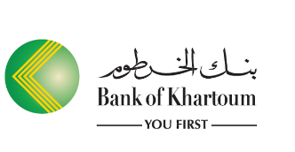
Worked as ICT Assistant to identify and troubleshoot issues which affects IT Environment of the Business, Providing 1st/ 2nd Line support over the telephone and remotely help desk services to large Organization.
Duties:
• Works remotely to provide 24x7 supports on critical systems to determine call types, failure Provide first level contact and convey resolutions to customer issues
• Properly escalate unresolved queries to the next level of support & Follow up & update customer status and information
• Expertly maintains data files and control procedures for a complex system of networked computers.
• Assigns passwords, monitors use of resources, backs up files daily and helps to define requests for information.
• Discovers and communicates potential service problems through identifying patterns occurring across separate help desk tickets and customer reports.
• Identifies, diagnoses and resolves Level One problems for users of the mainframe, personal Computer Software and hardware, Internet and new computer technology
• Email configuration in Outlook and other email client Application with their Business Environment.
Graduation:
Bachelor of Science in Information Technology, Ribat National University, Khartoum, Sudan (2006-2010)
Technical Certifications:
MCSA (Microsoft certified solution associate) MCP ID.13882543-2016
ACSE certified -2013
Technical Skills:
- A good working knowledge of all levels of Technical &helpdesk support.
- Well experience in Remote tools like Teamviewer , Logmein, windows RDC,VNC.
- Diplomatically manage user’s expectation.
- Experience in setting up and maintaining hardware and software systems.
- Experienced in Computer Hardware Solutions, Assembling &Repairing Computer Devices.
- Very well in Networking Cisco routers and switches configuration and installation.
- Mac OSX troubleshooting installation and upgrade.
- PBX configuration.
- VMWare administration.
- SAP ERP systems end user support.
- Skills in Workgroup & Domain Systems in all MS Operating Systems (XP, Vista, Windows7, Windows8& 10).
- Knowledge & Experience in WindowsServer2012, 2008, 2003 &Mac Operating System.
- Experienced in any kind of USB & Network Printers Installation in any OS &configuration and troubleshooting of MS Outlook.
- Well Knowledge in Active Directory Users and Computers, OU and Group Policy.
- SLA management.
- IT ticketing systems.
- ITIL process framework.
- Administrative and management skills.
- Ability to work shifts and weekends occasional overtime/overnight.

