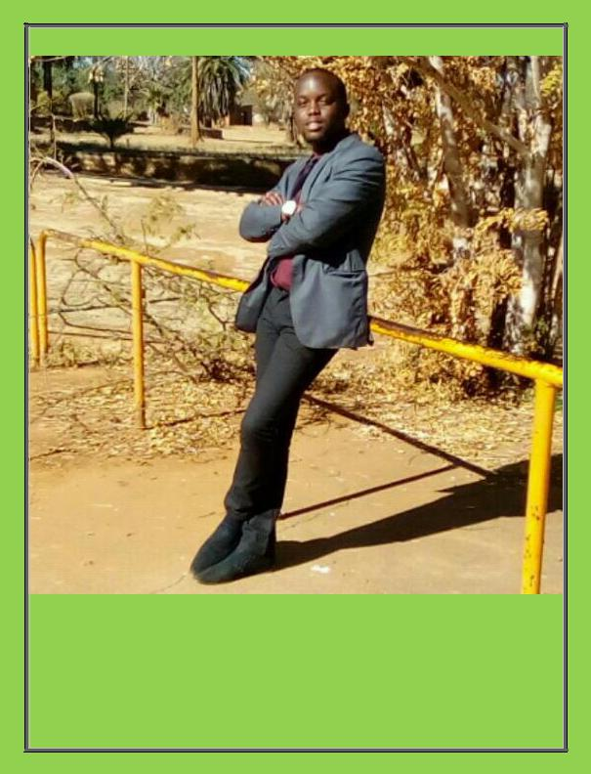

CURRICULUM VITAE

CALVIN CALVIN.372895@2freemail.com

PERSONAL DETAILS

NAME:

SURNAME:

AGE:

D.O.B:

NATIONALITY:

GENDER:

LANGUAGES:

RELIGION:

CALVIN

MOYO

25

25 AUGUST 1992

ZIMBABWEAN

MALE

NDEBELE, SHONA AND ENGLISH

,

ZIMBABWE

CHRISTIANITY

RESEARCH INTERESTS

- EVALUATION OF STRUCTURAL INTEGRITY OF EXISTING BUILDINGS, BRIDGES, DAMS AND OTHER CIVIL INFRASTRUCTURE USING FINITE ELEMENT ANALYSIS AND SIMULATION.

DISSERTATION PROJECT

- DESIGN OF STRUCTURAL STEEL ROOF FOR ENTIRE BABOURFIELDS STADIUM TERRACES.

- ACADEMIC SUPERVISOR: ENGINEER V. V. DESAI

ACADEMIC QUALIFICATIONS

Tertiary Education: Completed Bachelor of Engineering Honours Degree in Civil and Water Engineering 2017.

Degree Class |  | 2.2
First Year |  | 2.2
Second Year |  | P
Third Year |  | 2.2
Fourth Year (Industrial Attachment) |  | 2.1
Fifth Year |  | P

NATIONAL UNIVERSITY OF SCIENCE AND TECHNOLOGY (NUST), BULAWAYO, ZIMBABWE

- Secondary Education:

MPOPOMA HIGH SCHOOL, BULAWAYO, ZIMBABWE

- 3 Advanced Level passes in Mathematics, Physics and Chemistry 2010.

- 9 Ordinary Level Passes in 2008.

TEACHING AND MENTORING EXPERIENCE

MPOPOMA HIGH SCHOOL, BULAWAYO, ZIMBABWE 2011

- ORDINARY LEVEL MATHEMATICS TEACHER

HAMILTON HIGH SCHOOL, BULAWAYO, ZIMBABWE 2012

- MATHEMATICS, SCIENCE AND A-LEVEL CHEMISTRY TEACHER

PROFESSIONAL EXPERIENCE

WINNERMAN ENGINEERING, BELMONT BULAWAYO JUNE 2014 – JUNE 2016
- STUDENT ATTACHEE CIVIL AND CONSTRUCTION ENGINEERING

- ACTIVITIES AND REGULAR DUTIES:

  - ANALYSIS AND DESIGN OF STRUCTURES.

  - PROJECT PRICING.

  - PREPARATION OF BILLS OF QUANTITIES, MATERIAL SCHEDULES AND PROGRAM OF WORKS.

  - DRAFTING OF LAYOUT AND WORKING DRAWINGS.

  - REINFORCED CONCRETE DESIGN AND DETAILING.

  - TEAM LEADER IN FABRICATION AND INSTALLATION OF STRUCTURAL STEEL WORKS.

  - SUPERVISION OF SITE CONCRETE AND STEEL CONSTRUCTION WORKS.

COMPUTER SKILLS AND SOFTWARE
- MICROSOFT OFFICE EXCEL, WORD, POWER-PPOINT, MICROSOFT PROJECT AND PUBLISHER.

- PROKON STRUCTURAL ANALYSIS AND DESIGN

- PORTAL PLUS PORTAL FRAME DESIGN SOFTWARE

- LISA FINITE ELEMENT ANALYSIS SOFTWARE

- AUTOCAD 2D DRAFTING AND 3D MODELLING

- ARCHICAD

- AUTODESK SIMULATION MECHANICAL (FINITE ELEMENT ANALYSIS SOFTWARE)

TECHNICAL SKILLS
- LEVELLING TECHNIQUES USING DUMPY LEVEL

- SETTING OUT ON SITE

PROJECTS DONE
- SEKE TEACHERS’ COLLEGE, CHITUNGWIZA, GRADUATION HALL STRUCTURAL STEEL

- BARCLAYS BANK JMN NKOMO STREET, BULAWAYO, MEZZANINE FLOOR REINFORCEMENT

- CELEBRATION CHURCH HOW MINE, BULAWAYO, HALL FOUNDATION AND STRUCTURAL STEEL

- CELEBRATION CHURCH COWDRAY PARK, BULAWAYO, SETTING OUT OF ALL BUILDINGS

- CELEBRATION CHURCH ESIBOMVU, ESIGODINI, SETTING OUT, FOUNDATION AND STRUCTURAL STEEL

- ECOBANK ARCHIVE BUILDING, BELGRAVIA, HARARE, STRUCTURAL STEEL FABRICATION AND INSTALLATION.

HOBBIES

- TENNIS, CYCLING
- CHESS, POOL

- OUTGOING AND BRAAI

- SOCIAL NETWORKING

