ANIL
ANIL.372911@2freemail.com
JOB OBJECTIVE

Seeking senior level assignments in Financial Accounting / Budgeting & MIS / Costing with a growth oriented organisation

PROFILE SUMMARY

- A result oriented professional with nearly 18 years of experience in Accounts & Finance functions in U.AE
- Currently associated with MUBARRAZ OILFIELD INSTALLATION L.LC, ABU DHABI as Chief Accountant.
- Experienced in finance functions including maintenance & finalization of accounts, working capital management, profit monitoring, building internal financial controls, etc. as per IFRS & US GAAP standards,
- Knowledge of VAT – Input Vat-Output Vat calculations, reconciliatiosn & VAT Return filing procedures .
- Skills in managing employee database with proven success in implementing systems for payroll / time office and employee welfare functions
- Understanding in formulating budgets, implementing systems/procedures, conducting ageing analysis, preparing key reports to exercise financial control and enhancing overall efficiency of the organisation
- Soft Skills:
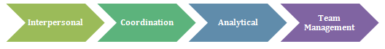

AREAS OF EXPERTISE

- Preparing & maintaining statutory books of accounts and reconciliation of financial statements in compliance with the norms; ensuring smooth operations of banking process
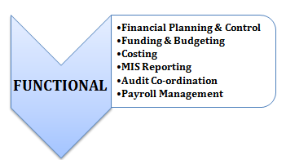
- Presenting a true and fair view of the financial position of the company by way of timely preparation of annual reports ensuring analyzing the expenditure on a monthly basis to control expenses & knowledge of Tax .
- Maintaining MIS & reports, evaluating them for facilitating decision-making process
- Liaising with banks for optimum utilization of available cash credit limit; taking care of financial systems and management procedures by means of proper budgeting & ensuring that controls are adequate
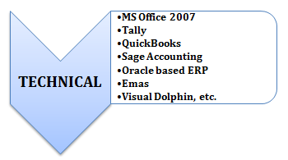
- Administering treasury functions including optimum utilization of surplus funds; controlling management of funds & securities ensuring pay-in/ pay-out of funds in time without fail
- Handling payroll processing functions involving computation of salary, preparation of salary certificate; processing joining/separation orders, increments, etc.
- Managing payroll function for employees involving processing of leave travel assistance, medical claims, joining expenses with reference to policies, final settlements, etc.

ORGANISATIONAL EXPERIENCE

Since Jan-2014 till Date
Mubarraz Oil Field installations .L.L.C –Position –Chief Accountant.
Abu Dhabi
Jul’04: Emirates Yedesa Factory LLC, Ajman
Chief Accountant Growth Path:
Jul’04-Aug’06 Cost Accountant
Aug’06-Till Dec-2013. Chief Accountant

Highlights:
- Oversaw wide gamut of tasks involved in accounting with team size of 10 members viz., finalization of accounts as per IFRS, budgeting, fixed assets’ purchase, inventory management and payroll
- Efficiently compiled and presented an array of financial statements - Income Statement, Balance Sheet, Cash Flow Statement, Retained Earnings Statements, Management Reports including Overhead Analysis, etc.
- Successfully:
- Carried out financial analysis to aid decision makers and thereby contributed to cost allocation, product pricing and overhead expenses
- Facilitated external audits through coordination and implementation of procedures and creation of reports
- Worked in close relation with banks for L/C transaction and other facilities
- Significant contributions towards streamlining the internal control system through ERP implementation, saved the overall cost by 5% on monthly basis
April- 98 to June-2004 Lifco Group of Cos
Accountant

Highlights:
- Played a key role in maintaining entire books of accounts, inventory records, cost sheets for imported goods, credit control, collection follow-up, etc.
- Steered initiatives towards payroll management for over 250 employees
- Adeptly provided sales support; prepared & furnished sales & margin and performance reports of sales personnel
- Rendered support to audit team; formulated an audit plan, coordinated with Auditor and assisted in preparation of auditory reports
- Liaised with banks & other financial institutions for facilities TR, Bill Discounting, L/C transactions, documentation and general banking operations

Commenced career with LIFCO Group of COS, Dubai as Accountant from Apr’98 to June-’04

SKILL ENHANCEMENT

- IMA Webinar & ERP Software Implementation Meet during 2013
- Attending work shop on Value Added Tax ( VAT) Training -2017

EDUCATION

2004 Masters in Business Administration - Finance
MG University,kerala, India

1993 Bachelors in Commerce
University of Kerala, India
.

2015 Certified Management Accountant (Part I)

Institute of Management Accountant, US

