RESUME
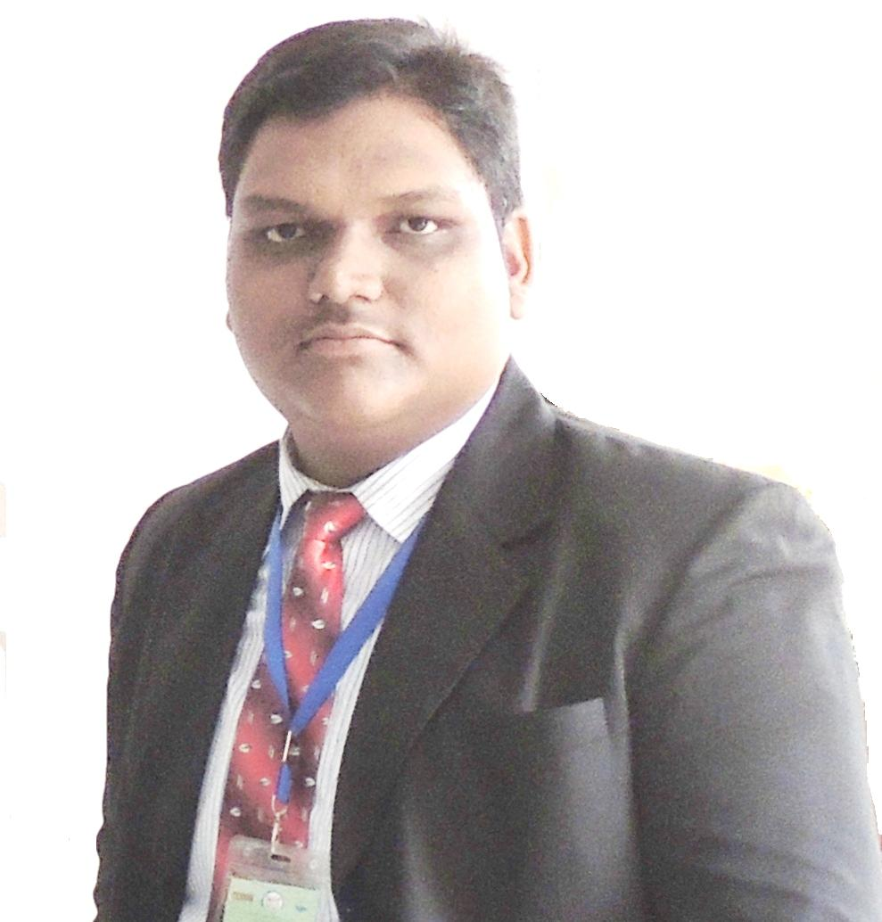
Mr. Ajit
Ajit.372917@2freemail.com
Asst. Manager HR with India Experience

PROFESSIONAL PROFILE
An energetic and credible HR professional with significant exposure to delivering business relevant HR initiatives within dynamic environments in the Middle East

OBJECTIVE
Maintain and enhance human resources productively in an organization, developing strong manpower, identifying talent and deploying professional development programs in order to achieve organizational goals and fulfill employees’ needs.

KEY SKILLS
Manpower Management (Recruitment & Selection), Organizational Development, Job Evaluation, Grading & Performance Appraisal, Succession Management / Talent Management, Compensation Management, Employee Welfare, Performance Management

PROFESSIONAL EXPERIENCE: 5 years of experience
Organization: ITR
Asst. Manager (HR and Operation) March 2013 to till now

Responsibilities and Role details:
- Recruiting and staffing,
- Posting of Job Description on Job Portals.
- Recruit graduates of colleges, universities and other educational institutions
- Strategizing long/ short term directions by forecasting the future manpower requirement and designing plans for acquiring requisite skills and competencies.
- Policy development and documentation.
- Performance Management & Improvement systems.
- Organization development, HR Audit, Employee Orientation and Training.
- Employment and compliance to regulatory concerns, Company employee and Community communication.
- Also responsible for Compensation and Benefits administration,
- Employee relations, Employee safety, welfare, wellness and health and counseling.
- Leave Management
- Ensure proper management of Staff amenities and occupational and health safety
- Exit Formalities

Organization: Interscience Group
Asst. Manager (HR and Operation) From Jan 2012 to Jan 2013 (1.1 Year)

Responsibilities and Role details:
- End to End Recruitment
- Screening of resumes. Short listing of resumes. Email communication to potential candidates.
- Follow up with candidate pre-joining and post-joining, sorting the queries.
- Employee Communication and Grievance handling.
- Joining Formalities, Checking the documents.
- Maintaining personal Files, Leave Management
- Employee Welfare/ Event Management
- Exit Formalities

Organization: Zep Infratech Limited
Designation: Project Engineer From Oct 2009 to Nov 2010(1.1 years)

Responsibilities and Role details:
- Work as Chief Engineer for Uninor project in Odisha.
- Manage projects Independently of Uninor, Odisha Region.
- Manage the vendors. Manage Payments for Vendors
- Manage projects of Vodafone, Odisha.
- Manage the Supply chain from Warehouse of Reliance Project.

EDUCATION & QUALIFICATION
- PGDM/MBA in HRM from IIMT (AICTE & HRD of India) with CGPA-7.6 out of 10 from(2010 to 2012)
- B-TECH in Electronics & Telecomm. from Biju Patnaik University of Technology (BPUT) with CGPA 7.0 out of 10 from (2005 to 2009)

COMPUTER SKILLS
- Microsoft Office 2007 - Word, Excel, and PowerPoint , CorelDraw

ADDITIONAL SKILLS
- Official social media account management skill
- Excellent event and Conference management skills
- Excellent Corporate Boucher, Magazine designing and Printing management skills
- Skilled in Microsoft Office (Word, Excel, PowerPoint).
- Excellent presentation slide making skills

LANGUAGES
- English – Excellent reading, writing and speaking
- Hindi – Excellent reading, speaking
- Odiya – Excellent reading, writing and speaking

PERSONAL DETAILS
- Date of Birth: 26.11.1988
- Sex: Male
- Marital Status: Married
- Religion: Hindu
- Nationality: Indian
ADDITIONAL INFORMATION: I have visited Dubai, Hong Kong, Bangkok, Bali and Kuala Lumpur during my Job.

