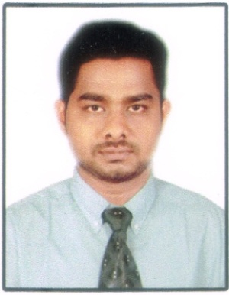
RESUME
ABDUL
ABDUL.372918@2freemail.com

Objective:

Cisco Network Engineer with an exceptional ability to build user-friendly networks of any size seeking the opportunity to become an asset to a company and its employees.

Cisco Certification:
- Cisco Certified Network Associate in 2015. Cisco ID

Work Experience:

Period Company / Project / Position / Work Description

June 2014 ZAZZY TECHNOLOGY PVT LTD, MADURAI
to
June 2017

NETWORK ENGINEER
- Duties
- Install & Upgrade Operating System, Drivers and Applications.
- Replace Defective Hardware’s in Clients and Servers.
- Provide Remote/Desktop Support for all Workstations.
- Configure & manage all type of Networks.
- Installation and Troubleshooting of PABX Telephones.
- Troubleshoot Server, Desktop, Network Related Problems & Errors.
- Design & Cabling for Networking.
- Hardware & Software Firewall Configuration.
- Installation and Troubleshooting for various biometric devices.
- Troubleshooting of PC's, Laptops, Printers, CCTV Cameras, DVR's, Biometric Devices.
- Configuration of ADS, DHCP, DNS and Active Directory Group Policy Objects (GPO).
- Routing Configuration (RIP, EIGRP, OSPF & ACL).
- Configure STATIC ROUTING, VPN, NAT.
July, 2013 DATAMARK PRODAPT PVT LTD, CHENNAI
to
May, 2014
Technical Support Engineer:
- Duties
- Research and identify solutions to software and hardware issues.
- Diagnose and troubleshoot technical issues, including account setup and network configuration.
- Track computer system issues through to resolution, within agreed time limits.
- Talk clients through a series of actions, either via phone, email or chat, until they’ve solved a technical issue.
- Document technical knowledge in the form of notes and manuals.

Educational Attainment:

• Tertiary ‐ Mount Zion College of Engineering and Technology, Pudukottai.
B.E computer science and engineering
Year Graduated – 2009‐2013
• Secondary ‐ APSA Matriculation Higher secondary school.
Year Graduated – 2008‐2009
• Matriculation ‐ APSA Matriculation Higher secondary school.
Year 2006-2007
• Computer
Knowledge ‐ MS Office, Excel, Word, CCNA, Command Excel Formula

Personal Information:

Date of Birth : October 02, 1991
Age : 25
Sex : Male
Civil Status : Single
Citizenship : Indian
Religion : Islam
Languages known : English, Tamil,

Declaration
I hereby certify that the above information is true and correct.

