C.V
Moustafa
Moustafa.372926@2freemail.com
Age (28 years)
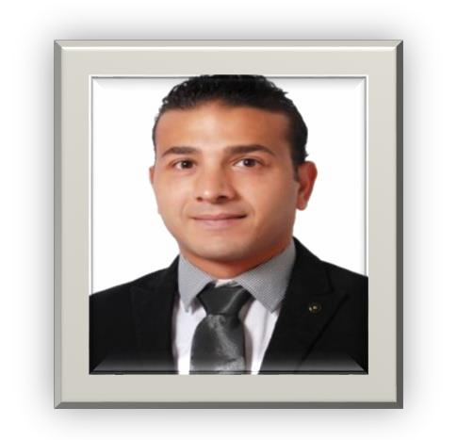

Personal Data
Nationality : Egyptian
Military state : finished an Enrollment Spare officer (from 2013 to 2016)
Address : Elkholy Street
Elmonshah Sohag
.
Education
University : sohag university College : faculty of science Graduation year : 2012 year

Objective:
Seeking a challenging position among a well established organization that has the need for my qualifications, using my skills and commitment to perform quality work; and offers opportunities for advancement.

Computer skills:
Excellent general computer handling and typing. Microsoft Office (Word –Excel-Access-Powerpoint)

Language skills:
Arabic: Mother tongue.
English: very Good Written and Spoken – course online.

Personal skills:
Excellent communication skills. Manage stress
Like challenges.
Has the ability to work under pressure with high performance level.

Previous Experiences :
Summer training in misr petroleum company
Search in DNA- RNA ( very good)

.Background as Document Controller at Dubai

Hobbies
Reading.
Learning New Language.

