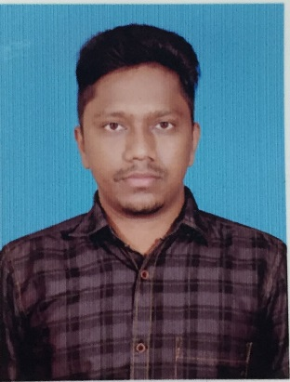  NAME: Sudhakar  E-Mail:  Sudhakar.372941@2freemail.com  Personal Data  Date of Birth : 22nd May 1990  Sex : Male  Nationality : Indian  Marital Status: Married  Languages Known: English, Tamil & Telugu | Objective  To seek a challenging job that will give me platform to combine ability and utilize my knowledge towards the best.  Academic Record  - B.Com (S.T Arts and Science College) from 2008 to 2011.  - Higher Secondary (Princess Mat. Hr. Sec. School) from 2006 to 2008.  - 10TH Standard (Princess Mat. Hr. Sec. School )  EXPERIENCE SUMMARY :  Recent Employment :-  Organization: DXC Technologies (Old Name: Hewlett Packard)  Designation: Financial Associate III  Applications : SAT, JBA  Duration: 28th May 2014 to 6th June 2017.  Job Profile:  - Verify that transactions comply with financial policies and procedures  - Review invoices from JBA and SAT.  - Maintaining TAT on daily basis.  - Handling client emails and vendor queries.  - Generating daily reports and status has been shared to clients.  - Received Star Performer Award for maintaining production with quality  - Issue payment on daily basis with client approval.  - Create payment file on weekly Basis and upload in bank upon client approval.  Previous Employment :-  Organization: IQ Backoffice India Pvt. Ltd  Designation: Senior Process Associate  Applications : SAP, Archimedes  Duration: August 10th 2011 to 26th May 2014  Job Profile:  - AP process for leading clients in US.  - Processing manual payment for immediate transactions.  - Review invoices, check requests, statements.  - Allocating work to associates and maintaining the team to complete the work before EOD with quality.  - Handling client emails and vendor queries.  - Vendor Statement reconciliation.  - Managing month end process.  Technical Skills  Operating System: Windows Family  Packages : MS Office & Tally 9.0  Competencies  - Fast Learner.  - Organized and well-structured at work.  - Independent and self-motivated.  - Good team player.  - Honest, Sincere and a Hard Worker with a high level of Integrity.  Declaration:  I hereby declare that the above particulars furnished by me are true to the best of my knowledge and belief.

