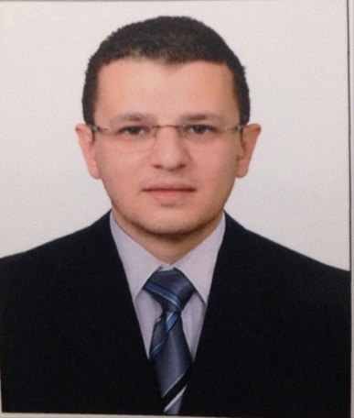
Mohamed
Mohamed.372944@2freemail.com
UAE

Objective:
Seeking a challenging position with a successful organization, where by my hard work allows me to use my skills and prove myself and to gain additional business experience and achieve the goals of the organization in order to create mutual benefit.
Employment Profile:
- Samsung Gulf Electronics Dubai - UAE
Call Center Technical Support From July 2015 - Present
Work Scope:

- Deliver the best service that the user can get by resolving his/her issues or escalating the issue to the concerned department; moreover follow up with the concerned department to have the issue fixed at earliest to ensure the user’s satisfaction.
- Provide Exceptional Customer Service to the business user by answering the calls with proper greetings, promoting a positive image of the department, resolving problems with professional manner, maintaining quality in performance.
- Log all calls in the service manager and act according to the severity of the call. Make sure the logged calls are categorized in the right manner and assigned to the right team.
- Communication with the business users, and ensure that their expectations are met through first and second level problem determination and problem resolution efforts.
- Resolve first level technical support associated with hardware and software problems. Isolate.

- MAF Carrefour LLC Dubai - UAE
Team leader for Customer Service From June 2013 - Feb 2015
Work Scope:

- Receiving escalated customer issue to customer service desk.
- Preparing financial report for financial management.
- Making refunds and exchanges as per customer desires to achieve highest customer satisfaction level.
- Handle product inquiries of clients.
- Listen to customer concerns.
- Arrange special event or product launch.
- Handling all cashiers
- Achieving required customer satisfaction level
- Enlarge client base by developing excellent customer relations.
- Survey, analyze and prepare proposals for new prospects and old clients.

- MAF Carrefour LLC Alexandria - Egypt
Senior Cashier Feb 2012 - May 2013
Work Scope:

- Greet customers and satisfy each customer’s wants and needs.
- Handling all types of cash counters.
- Trying to get the highest customer service level all the times.
- Handling all issue in cash process especially in Rush hours.
- Monitoring cash flow process and deliver feedback to financial management.
- Maintain strong and effective relationships with the customers.
Specialties Keys:
- Very Good Communication Skills
- Handling customer's problems and satisfying their needs
- Sound Knowledge of Administration & Finance related matters
- Generate activity and seek new challenges to improve work performance
EDUCATION
Bachelor of commerce - Faculty of Commerce, Alexandria University 2012
Language:
Arabic: Mother tongue
English: Very Good (reading, writing and speaking)
Personal Skills:
- Hard Worker
- Positive Attitude
- Dependable and responsible
Computer Skills:
Operating Systems: Dos, Win 9x, Win NT, Win Me, Win2000, Win XP and Win 2003 server.
Microsoft Office (2003, 2007, 2010, 2013) (Word, Excel, PowerPoint, Outlook)
General: Easy Deal with Any Software.
Personal Information:
Nationality Egyptian
Date of birth 01/09/1987
Marital status Single
Visa Status Employment Visa

