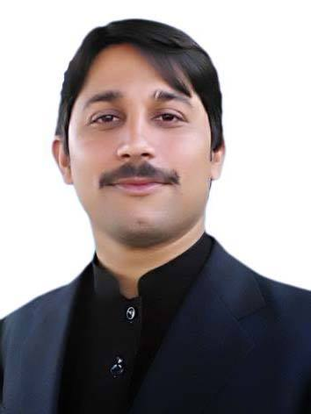
OSAMA
Email: osama.372958@2freegmail.com

Professional Objective
To become a part of well-developed organization for utilizing and exploring my knowledge, skills and abilities so as to make a positive contribution to the organization’s effectiveness accordingly.
Summary
Master in Business Administration (MS), Equipped with More than One Year of Professional Experience as an Accounts/Office Assistant at Shahnawaz Enterprises Peshawar and as an Internee at NBP.
Academic Qualification
MBA (MS) University of Peshawar 2014- 2015 3.0 CGPA
BBA (Hons) University of Peshawar 2009- 2013 3.7 CGPA
DBA MCCM Peshawar 2007-2009 76.28% Marks
Matric H.S.T.M School Charsadda 2006-2007 66.00% Marks
Professional Experience
Organization: SHAHNAWAZ ENTERPRISES PESHAWAR (SNE)
SNE is pharmaceutical distribution in Afghanistan since 1999 which provides patients and doctors with disease and treatment awareness and provides uncompromised quality medicines of different multinational and national companies as well as own medicine for patients.
Position: ACCOUNTS ASSISTANT cum OFFICE ASSISTANT
Period: From May, 2016- To Present
Location: U.G-16, PAK BUSINESS CENTRE, G.T ROAD, PESHAWAR, PAKISTAN
Duties and Responsibilities:
- Maintaining account system.
- Managing daily receipts and payments and cash balance.
- Banking money and cheques and issuing receipts as requested or needed.
- Maintaining bank relationships.
- Payment of invoices etc. as instructed.
- Managing and recording company’s and supplier’s claims.
- Managing employee’s attendance record and preparing salary sheets.
- Preparing and recording Field Force salaries, travelling and other expenses.
- Acting as point of contact between internal and external individuals.
- Meet and Greet guests and visitors etc.
- Maintaining and monitoring supplies, materials and inventories.
- Responsible for book-keeping and filing documents.
- Forwarding information by receiving and distributing communications like phone, mails and letters etc.

Organization: National Bank of Pakistan (NBP)
Position: INTERNEE
Period: June, 2012 to August, 2012
Location: Tehsil Bazar Branch Charsadda
Worked in Following Departments:
- Account Deposit, Clearing, Remittance, Bills, Advances, Account Opening.
Skills and Abilities
Technical Skills:
- MS Word, Excel, Power Point (Having a Certificate in MS OFFICE, from Frontier College Charsadda)
- In-page
Professional skills:
- Strong Financial and Administrative skills.
- Excellent communication and presentation Skills.
- Ability to handle multiple tasks even in stress.
- Strong leadership and interpersonal skills to work with and inspire others.
- Proactive ability and strategic thinking to see the organization future.
Personal Details

Date of birth : 03 April, 1990

Nationality : Pakistani
Religion : Islam
Languages
English : (Reading, Writing and Speaking)
Urdu : (Reading, Writing and Speaking)
Pashto : Native
References: Available on Demand

