JYOTHIS
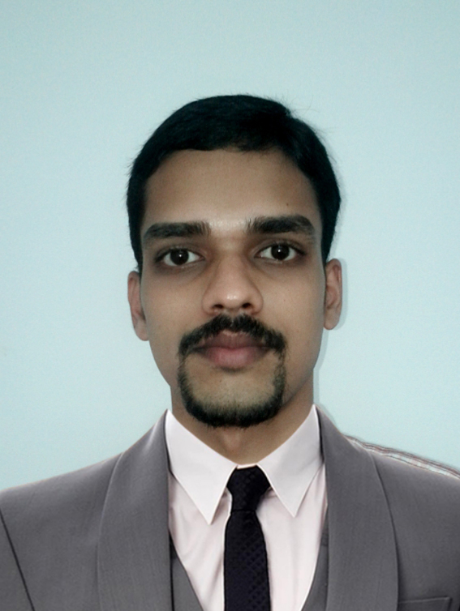

Photograph

JYOTHIS.372970@2freegmail.com

CAREER summary:
I am an accomplished Electrical and Instrumentation Engineer with a background in commercial and industrial installations including knowledge of Fire Fighting and HVAC works in construction field.
I have an in depth knowledge of electrical systems and I am looking to expand my experience within a role that combines new builds as well as contracts.

professional experience:

- Currently working as Electrical Engineer (Handling both Electrical and Instrumentation section) at Envicon Emirates, Abu Dhabi, United Arab Emirates (From February 2016 to till now)

Responsibilities includes but not limited to following,
- Acting as the main technical adviser on a construction site for subcontractors, crafts people and operatives.
- Managing the site, checking plans, drawings & quantities for accuracy of calculations, ensuring that all materials used and work performed are as per specifications.
- Overseeing the selection & requisition of materials.
- Managing, monitoring & interpreting the contract design documents.
- Handling cable tray & cable trunk installation, cable pulling & termination, cable testing, installation of control panels, junction boxes & distribution boxes.(For both electrical and Instrumentation systems)
- Liaising with consultant, subcontractors and the general workforce involved in the project.
- Liaising with clients and their representatives, including attending regular meetings to keep them informed of progress in day to day site management.
- Planning the work and efficiently organizing site facilities in order to meet agreed deadlines.
- Overseeing quality control and health & safety matters on site
- Preparing reports as required for work progress
- Resolving any unexpected technical difficulties and other problems that may arise in construction side.
- Worked as Electrical and Instrumentation Engineer at Arvin Technologies, Kochi, Kerala, India. (From September 2013 to January 2016).

Responsibilities includes but not limited to following,

- Review execution plans, construction deliverables, E & I deliverables and risk assessment to ensure work can be executed safely and effectively within timescales.
- Review Single Line Diagrams, Piping & Instrument drawings etc. for material selection and submittal.
- Developed detailed work scope for E & I.
- Testing and Calibration of E & I Equipment/instrument.
- Inspection of electrical/instrument materials to ensure alignment with project’s statement of work.
- Provide Detailed Project Reports to construction lead on daily E & I activities.
- Worked with PLCs and DCS systems, on wiring practices and panel designs, instrumentation wiring practices and PLC Hardware and Software.
- Provide technical support to maintenance, operations and technical service on automation and instrumentation problems including issues related to the distributed control system, analyzers and programmable logic controllers.
- Programming of PLC and DCS systems by using Ladder and Functional block diagram languages.
- SCADA screen designing and interfacing with controllers.
- Control Panel Designing, Wiring and Installation and Commissioning of control systems.

major Projects HANDLED in uae:

- Infrastructure Development for Upper Zakum Island (UZ-750 Project) for ZADCO, Abu Dhabi, United Arab Emirates (From March 2017 to till now)

Position: Site Engineer (Onshore)
Client: ZADCO
Contractor: Petrofac Emirates
Scope of work: Erection of Electrical and Instrumentation works with respect to infrastructure buildings in Upper Zakum Central and West Islands. Fabrication works performed in onshore workshop and installation is done at offshore. (Handled Fire Fighting, HVAC and Electrical Fabrication works at Onshore)

- Construction of New Diary Farm, Nahel City, Al Ain, United Arab Emirates (From February 2016 to December 2016)

Position: Site Engineer.
Client: Al Ain Municipality.
Consultant: AECOM Middle East.
Scope of work: Erection of Substation (1500 KVA), MEP works for Labour Accommodation buildings, Erection and Installation of Pumping station for farm with both Automatic and Manual Control modes, Erection and Installation of Waste water treatment plant for farm with both Automatic and Manual Control modes.

- Operation and Maintenance of Two Waste Water Treatment Plants (STP), Al Khazna Tannery, Al Khazna, United Arab Emirates (From March 2016 to March 2017)

Position: Site Engineer.
Client: Al Ain Municipality.
Consultant: Hyder Consultants.
Scope of work: Daily based monitoring of plant. Blower and Filtration units up gradation with Automatic and Manual switching modes.

EDUCATIONAL QUALIFICATIONS:

Qualification | Institute/College | Board/University | Year of Completion | Mark
S.S.L.C.  (XTH) | St. Joseph’s High School, Kudakkachira, Kerala, India. | State board of  Kerala, India. | 2007 | 85%
H.S.C.  (XIITH) | Our Lady of Lourdes Higher Secondary School, Uzhavoor, Kerala, India. | State board of  Kerala, India. | 2009 | 75%
B.E.  (Electronics and Communication Engineering.) | Loyola Institute of Technology and Science, Nagercoil, Tamil Nadu, India. | Anna University Chennai, Tamil Nadu, India. | 2013 | 8.12  (CGPA)

CERTIFICATIONS:

- Obtained 6 months internship, Post Graduate Diploma in Industrial Automation from Technocrat Automation private limited, Chennai, Tamil Nadu, India (From March 2013 to August 2013).

- OPITO certification in Basic H2S and TSB Safety Procedures with respect to offshore works from Emirates Technical and Safety Development Center, Abu Dhabi, UAE ( In April 2017 and Valid for 2 years)

Personal profile:

Date of Birth : 03/06/1991.
Gender : Male.

Languages Known : English, Malayalam and Hindi.
Hobbies : Playing football and cricket, Social networking,

SALARY EXPECTATION:

Present Salary (Monthly) : AED 4000.00 / -
Expected Salary (Monthly) : AED 6000.00/-

DECLARATION:

I hereby declare that the above particulars furnished by me are true to the best of my knowledge and belief.

