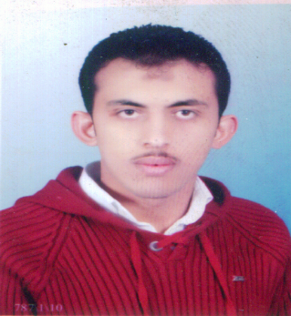
Curriculum Vitae

Adham

adham.372971@2freegmail.com

Personal Information :
- Nationality : Egyptian.
- Date Of Birth : 4/7/1988
- Place Of Birth : Diarb Negm,El-Sharkia,Egypt.
- Religion : Muslim.
- Marital Status :married.
- Military Service : Done.
Academic Education :
- University : Zagzig University .
- Faculty : Engineering.
- Department : electrical engineering department
- Year of Graduation : 2010 .
- Graduation Project : Radar System .
- Project Estimate : Excellent.

Language Skills :
- Arabic : Mother Tongue.
Reading | Writing | Speaking | Listening
Good | Good | Good | Good
- English :

Computer Skills :
- Operating System : Windows XP , Internet .
- Office tools : Word , Excel , Power point .

Training :
- Train is specialist company for Building BTS for Vodafone in 2008
_Train in petro pel gas company in the summer of 2007
Courses :
Scaffolding & OSHA 30 & OSHA 44 & NASP & Risk assement & fire fighting
And ohsas 18001

WORKS :
1: Foundation international contracting from 1_12_2010 until 1_12_2013
2: works as safety engineer in special contracting company from 3_2014 until2015
3: works as safety engineer in bin ladn (SBG) from 5_2015 until now

-First work in abraj kudai which consist of 12 tour as safety engineer for 5 months

-Then go to work at security building at plot3 and work as safety manager for concerete division department and become safety manager for plots 3 & marwa station and gabal el kaaba station at the same time for 4 months and I have some mails from high ministry of education for my good work and lead

-Then I back to abraj and become the afternoon shift manager and my team consist of 6 safety engineers and 35 officer I lead all of them until now kudai in febraury

Notes ….
I study nebosh this days to take the certificate at the nearest time
I am in United Arab Emirates now

