Jeetan
Jeetan.372974@2freemail.com
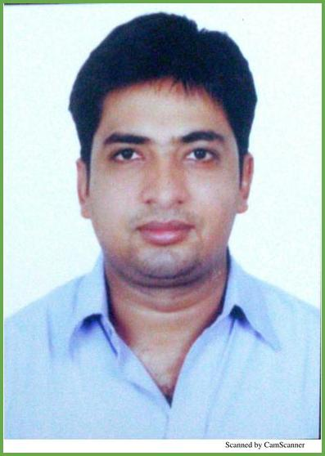
Sales Manager

Summary
A result oriented professional with more than 17 years of experience in Sales, Operations, Customer Management, Business development & Channel management. Recent designation as a Sales Manager with Glaze granite & Marble tr est . Track record of increasing revenues, streamlining workflow and creating a team work environment to enhance profitability. Adequately experienced in conceptualizing new business plans to enhance operations, with a proven track record of developing call center towards achieving organizational goals.

Skills
Channel Management

Operations Management

People management/ Training/ Recruiting

Contriving the Channel Policy and establishing the channel network including identification of potential partners, discussion and appointment. Controlling the operation related to logistics, appointing dealer/partner, overall management of the sales and service team.

Responsible for overall target achievement by effective Team Management.
Overseeing marketing and sales operations for achieving increased growth profitability.
Analyse reports with a view to monitor the performance & efficiency of team members, ensuring compliance with pre-set quality parameters. Development and implementation of all call centre procedures required for daily operations as well as design and manage the Work Force Planning Department.

Create and sustain an environment that fosters development opportunities & motivate high performance resulting in improved efficiency.
Define and monitor the Performance Management System as well as assist and support recruitment process.
Conducting practical and theoretical training programs, to enhance skills and motivational levels. Training new employees and incorporating the process of Mentor ship.
Oversee capacity planning and roster management, performing employee's quarterly yearly appraisals to manage performance..

Work experience
2014-12 - Present Sales Manager , GCC

Glaze Granite & Marble tr Est.

End to End Sales Operations in GCC.
Responsible for Channel Management, Distribution, B2B sales management. Monitoring performance of the sales team and addressing their shortcomings

Liaising with suppliers/warehouse managers on a day to day basis to ensure stocks are delivered on time and to schedule
Responsible for selling, closing, servicing and expanding the current customer base within an assigned Region
Selecting sites for new development and opportunities. Recently given the opportunity to develop network in African Region for which I visited Mauritius, Nigeria & Ghana.
Increasing sales and achieving targets .Maintain sustainable relationship with the clients and increase business from the existing client.
Communicating and servicing the clients on the daily basis to ensure highest standard of services are maintained.
2012-11 - 2014-09 National Sales Manager

Silvermoon Nigeria Ltd, Lagos - Nigeria.

Responsible for selling of(15-18) 40 feet Containers of stock-fish & dry fish heads per month.
Maintaining good customer relationship. Preparing monthly sales analysis. Involvement in planning & promoting the product for the growth of the company.
Making quarterly trips to Onitsha & Aba. Guiding procurement team for procurement of goods
Researched & found new suppliers which resulted in visits to Europe(Norway). Visits to Europe resulted in new procurement.
Doing a market Survey to decide the Selling prices of SKU based on current market information. Optimizing the allocation of the fish to the customers.
Enabling profit maximization & 100% sales of each consignment on cash & carry basis.
In absence of my colleagues I am able to do back up functions like Costings, Cargo Tracking, follow-up with clearing agents, prioritization to refer containers for no demur rage & port charges.
2011-01 - 2012-10 Sr Team Leader-Collections BPO

FCS INDIA PVT LTD

Managing team of 50 Tele-executives(direct payroll of FCS INDIA PVT LTD) and one outbound Call Centre‘ BPO, handling process called Auto Collections for U.S Clients, doing collections for Volkswagen and World Omni Financial Auto loans, earlier was handling the process of 60 Tele-executives for the process Zenith Acquisition services having mixtures of all Credit card charge out accounts, however the process was shut 1 month back.

Responsible for achieving targets on Daily LG Telesales. Developing & implementing collection strategy for the call centre operations & In house Tele team.
Scheduling and deployment of manpower, defining the productivity indicators per workstation and implementing process matrices to monitor the same.
Coordinating with the call centre management regarding the campaign & revenue expectations and assuring the matrices are defined based on efficiency, quality and productivity across all levels.
Assuring smooth flow of processes at an operational level, resolving any issues or conflicts at a tactical level. Initiate, implement and organize various motivational activities like Incentive schemes to increase performance Monitoring of Assigning and lead allocation job to various processes.
Co-ordinating with Operation managers of IM for feedback of Leads allocated from all sources.
Conducting performance reviews as well as analyzing data on critical success factors, and developing action plans to deliver a sustainable performance standards Sharing best practices with partner organizations to optimize the growth and improvised the quality of business.
2005-03 - 2010-12 Manager-Telesales (3rd Party Collection)

Zenta Pvt Ltd.

Key responsibilities to manage two outbound Call Centres for NCOIR Chase. 60 seater process for the charge bills of credit card, personal loans and mortgage accounts for J P Morgan Chase Bank USA“

Responsible for achieving targets on fresh business acquisitions through Telecollections and benchmark costs and compliance in B2C Channel.
Developing & implementing sales strategy for the call centre operations Scheduling and deployment of manpower, defining the productivity indicators per workstation and implementing process matrices to monitor the same.
Coordinating with the call centre management regarding the campaign & revenue expectations and assuring the matrices are defined based on efficiency, quality and productivity across all levels in order to increase HNI base.
Analyse‘ Customer Feedback' suggestions to improve productivity and deliver high level of‘ Customer Experience'; also adhere to the timelines for requests made by the customers.
Initiate, implement and organize various motivational activities like R&R, Incentive schemes to increase performance Conducting performance reviews as well as analyzing data on critical success factors, and developing action plans to deliver a sustainable performance standards Sharing best practices with partner organizations
2003-07 - 2005-01 Store Manager

Shamdas Kirpalani Pvt Ltd

Job profile included managing departmental store, handling petty cash transactions, valuation and stock management.

Handling petty cash and maintaining books for the department.
Handled accounts routine data management in electronics store accountancy.
Give routine data feedback to customer for new inventory of goods.
2001-11 - 2003-06 Sales Executives

Gitanjali Jewels Ltd(Gili). MUMBAI

Strengthening customer base & indulgent service consistently.
Supervising strength of staffs and developing team spirit.
Preparing monthly sales analysis.
Involvement in planning & promoting the product for the growth of the company.
Making duty schedules.
After sale services.
Dealing with luxury branded Jewellery for Gitanjali Diamond & Gold Jewellery. Carry out daily routine tasks as assigned, includes administrating mail, composing official memos, distributing documents, faxes, e-mails & screening and handling telephones call, enquiries and request .

Education
2011 - 2012 B.Com

Mumbai University

Specialization In Commerce

Personal Details
Date of Birth - 31st August 1982.

Marital Status - Married.

Nationality - Indian

Driving License- UAE

