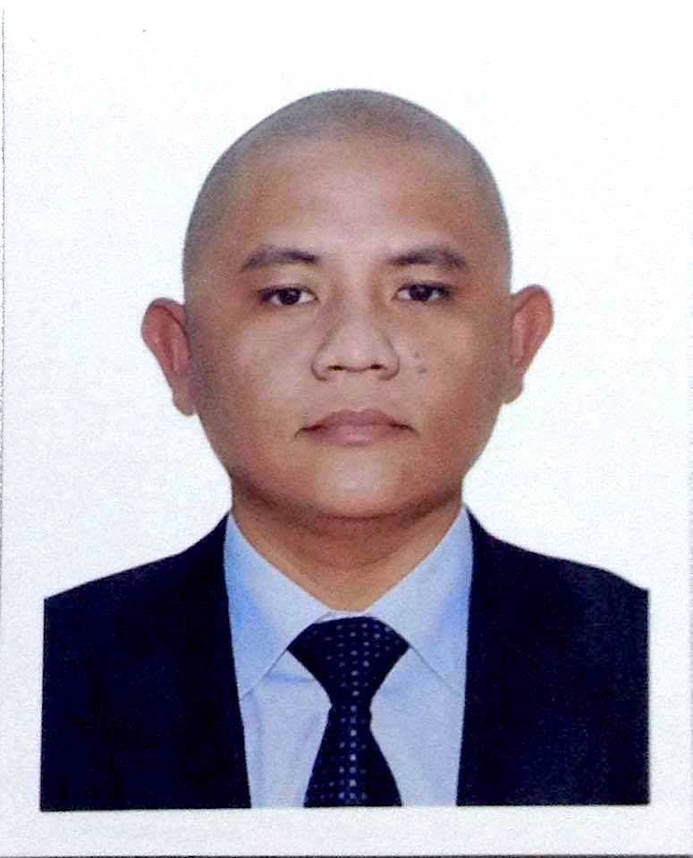
JAYPEE
JAYPEE.372989@2freemail.com

SUMMARY

- Experienced IT Manager with extensive knowledge in Information Technology and Security Solutions sales and services.

- Excellent in office administration, organization and time management.

- Vast knowledge in Office Software including Microsoft office proficient in MS Word and MS Excel, MS PowerPoint, Photoshop, Active Directory and several IT languages, including HTML, PHP, MySQL

- Knowledgeable in office equipment management including computer software and hardware installation and maintenance, computer networking configuration, printer setups, CCTV security system, Time Attendance System and Computer Servers.

- Experienced managing professional installation and maintenance team, well-organized office administrative staffs, productive IT solution and Telecom Internet Broadband Sales Team.

- Interested to fill any suitable position and willing to do extra work that will further develop personal and career growth in order to provide a proper service to the company.

TECHNICAL SKILLS

Skills | Skill Level | Last Used
MS Word, Excel, PowerPoint | Advance | 2017
TCP/IP Networking (Wired and Wireless) | Advance | 2017
CCTV Security System (Wired and Wireless) | Advance | 2016
MS Windows OS (XP, 7, 8, 10) | Intermediate - Advance | 2016
MS Windows OS (2003) | Intermediate - Advance | 2016
Adobe Photoshop | Intermediate | 2017
Adobe Dreamweaver | Intermediate | 2017
Html, Php, MySql | Intermediate | 2017
MAC OS | Intermediate | 2017
Door Lock System | Intermediate | 2015
Time Attendance System | Intermediate | 2015
Office Administration | Intermediate | 2016
Active Directory | Beginner – Intermediate | 2016
PABX (Private Automatic Branch Exchange) | Beginner | 2015
MS Publisher | Beginner | 2015

QUALIFICATION

- Knowledgeable in Office software including but not limited to, MS Word, MS Excel, MS PowerPoint, Adobe Photoshop, and Dreamweaver.

- Developed and implemented a data management system for office.

- Handle company’s important files, purchasing, quotation approval, payroll and stocks inventory audit, price updating, and monthly profit and loss assessment.

- Managed installation and maintenance of all office equipment including PC workstation, Printers, Scanners, Telephone system, Surveillance system, and Networking infrastructure.

- Managed all administrative duties including, Data Encoding, Marketing, Customer service, Sales productivity, Accountability, and Warranty.

- Experienced in Google Adwords setup, basic SEO management, editing Html and Php web program.

- Ability to organize, prioritize, work under work pressure and Flexible with willingness to do extra work.

WORK EXPERIENCE

Freelance Virtual Assistant January 2017 – May 2017
ARIEX INTERACTIVE INC.
2625 MIDDFIELD RD #220 Palo Alto CA 94306
Homebase: Tabuco Naga City Camarines Sur Philippines

Responsibilities:
- Providing various virtual assistance tasks, which include Data entry, Website Optimization for Facebook Advertising, Editing Html and Php programming codes.

Operation Manager June 2011 - December 2016
HDY GADGET REPUBLIC
#28 Door 1 JAM Bldg. Magsaysay Ave. Concepcion Pequena Naga City

Responsibilities:
- Overseeing and hands on assistance on all office administrative works including Pricing update via company POS, Stocks and Equipment’s Inventory, Warranty, Purchasing, Partners monthly Sales Record, Payroll, Data Encoding, Document filing, Front and Back office.

- Developed and maintain data management system via MS Excel, which increases admin efficiency.

- Monitor and provide hands on technical assistance to installation and maintenance team including Installation Planning and Implementation, Wired and Wireless installation of Computer Networking and CCTV Surveillance system, Biometric Time Attendance and Door lock system, Software and Hardware installation setup, Computer Servers maintenance.

- Planning monthly strategy for both Solutions and Telecom Sales Teams.

- Attending monthly alignment meeting with business partners.

- Setting and reviewing daily/monthly budgets and managing cost.

PCOS Technical Team Supervisor May 2010
(May 2010 National Election)
SMARTMATIC-TIM
Area covered: Lagonoy Coastal Area, Camarines Sur
Responsibilities:
- Managing 5 IT technicians assigned in 5 different barangays of Partido North Coastal Area to handle the PCOS (Precinct Count Optical Scan) voting machines.
- Monitoring and providing assistance to all Technical team.

Online C++ Visualization with Nov 2009 – Mar 2010
Exam Generator
Department of Computer Science, Ateneo de Naga University
Ateneo Avenue, Naga City

Responsibilities:
- College Senior Project, program state web-based visualization tool for enhancing introductory programming education with automate exam generator (Thesis author, software developer).

Network Maintenance and Sep 2006 – Jan 2008
DSL Installation Technician
BEACON COMPUTER
Penafrancia Ave. Naga City

Responsibilities:
- Installations and troubleshooting of ADSL modems
- Provide remote and on-site assistance to Digitel DSL CPE
- Provide assistance to Digitel Outside Plan and Transmission personnel

Freelance Software Developer Jan 2006 – June 2006
MARANTZ TAILORING
Barlin St., Naga City

Responsibilities:
- Develop Sales and Inventory System Software for Tailoring business (Team Project)

Courier Jun 2005 – Jan 2006
AIR21, MAIL & MORE
J. Hernandez St. Naga City

Responsibilities:
- Package house to house delivery
- Package inventory and sorting
- Front-desk officer

EDUCATIONAL BACKGROUND
Tertiary Level
Bachelor of Science in Computer Science March 2010
Ateneo de Naga University
Ateneo Avenue, Naga City, Camarines Sur Philippines

TRAINING and INVOLVEMENTS
Globe Telecom Level 1 Broadband Installer, Hdy Gadget Republic, Naga City, 2013

CHARACTER REFERENCES
Available upon request.

