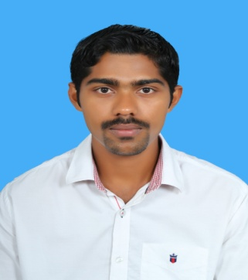
Robin
Robin.372994@2freegmail.com

Position as an engineer or related position which offers key participation, team oriented tasks, immediate challenges, and career opportunity.

EMPLOYMENT

OCTOBER 2016 – JUNE 2017 technical support engineer– ACUMEN TECHNOLOGIES, KANNUR, KERALA
Duties:
        - Maintained and administered computer networks and related computing environments including computer hardware, systems software, application software, and all configurations.
        - LAN/WAN Administration.
        - Managing the Retail ERP Software.
        - Project Management
        - Resolved various technical problems ranging from PC's, hardware, software, network printers, LAN/WAN.
OCTOBER 2014 – SEPTEMBER
2016 TEAM LEAD OPERATIONS – BIZMAX INFOTECH, oMAN
Duties:
        - Provided phone and remote desktop support to end-user.
        - Provided technical expertise for IT network design, implémentation, optimization and upgrade.
        - Monitored the LAN/WAN network environment including routers, switches, and Internet access and software applications.
        - Performed troubleshooting and diagnosis to hardware/software network failures, and provided resolutions.
        - Installation, configuration and maintenance of [Windows OS] system network components.
        - Ensured full and incremental data backups were successful; performed data restore for users as needed.
        - Assisted in the timely recovery of data lost due to software crash or hardware failure.
        - Managing the Retail ERP Software.
        - Allocating jobs and workloads to individual staff members based on their ability.
        - Implementing new initiatives and making sure all staff understand them..
        - Providing accurate information to senior managers on key issues.

EDUCATION

2010 – 2013 MASTER OF COMPUTER APPLICATION–MANGALORE UNIVERSITY
College: Srinivas Institute of Management Studies. Mangalore, Karnataka
Percentage: 70 %

2007- 2010 BACHeLOR OF COMPUTER APPLICATION– AMRITA VISHWA VIDYAPEETHAM UNIVERSITY

College: Amrita School of Arts & Science, Mysore, Karnataka
Percentage: 66 %

2005- 2007 plus two-KERALA BOARD
Institution: St:Mary’s College HSS, Kerala
Percentage: 64 %

PERSONAL PROFILE

Marital Status : Married
Nationality : Indian

Date Of Birth : 04-04-1989
Driving license : Indian & Oman (GCC Valid)
Languages : English, Malayalam, Tamil
Visa Type : Visit Visa (Exp 13th October 2017)

DECLARATION

I hereby declare that the above-mentioned information is correct up to my knowledge and I bear the responsibility for the correctness of the above-mentioned particulars.

