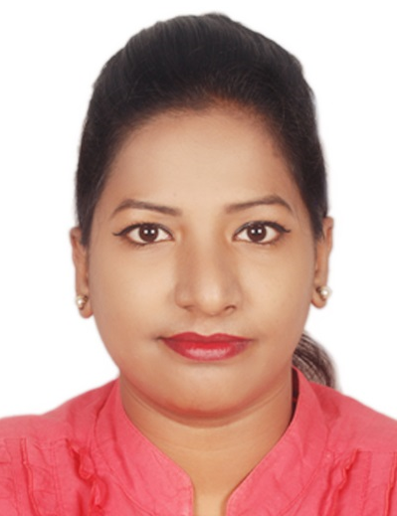
Name: Miss Rajeshree
Rajeshree.372997@2freegmail.com

.

saurabhsabnis@gmail.com

CAREER OBJECTIVE
To attain quality oriented result and achieve peak of success for the organization by inculcating my technical skills into practice.

WORK EXPERIENCE
- Name of the Organization: Wipro InfoTech (Working for Client – HDFC Bank)
Position Held: Technical Support
Duration: 28th May 2014 – 1st September 2015
Work Profile :
- Managing and Maintaining all troubleshooting related Network & Software related to Bank
- Configuring Lotus and other software installation
Achievements: I was awarded 6 time as a best employee in Wipro InfoTech

- Company : LG Solution Plaza
Position Held: Customer Care Officer
Duration:(21st Jan 2011 to 30 June 2013 )
Work Profile :
- Deal with all calls received within the Customer Service Centre in line with current Service Level Agreements, policies and any necessary follow-up work in relation to incoming calls.
- Day to day management. Manage customer services team to deliver what customers need and to
continually improve your customer service team’s efficiency and effectiveness.
Achievements: Exceeded the LG solution sales goals by effective up-selling of company’s AMC policy.

M.Sc IT | Kishinchand Chellaram College | Mumbai University | 431/600  443/600  451/600  426/600 | Aug’2017  Nov’2017  May’2016  Dec’2015 | Sem 4 – 69 %A Grade  Sem 3 - 74%  Sem 2 - 75.16%  Sem 1 - 71%
B.Sc IT | St. Peters College | Mumbai University | 603/750  497/750 | April’2014  Oct’2013 | Sem 6 – 80.04%  Sem 5 - 66.26%
H.S.C | S.V.M College | Maharashtra Board | 332/600 | Feb’2009 | 55.33%
S.S.C | Nirmala Mata Girl’s School | Maharashtra Board | 461/650 | Mar’2007 | 70.92%

COMPUTER SKILLS
Networking, SQL Database, Software testing.
Microsoft certification in Network security.

PERSONALITY TRAITS
- Team spirit and can work individual as well.
- Adaptive, determined, focused and quick learner.
- Good management and communication skills.
- Keen and interested to learn new things.
- Interest in learning Technologies
- Presentation Skills
- Punctuality

ACADEMIC PROJECT
Cryptography Based on Color Substitution.
Language Of Implementation : ASP.Net
System Processor : Above Windows 98 &Intel Core Processor

Project Description:
- In this project, an innovative cryptographic substitution method is proposed to generate a stronger
cipher than the existing substitution algorithms. This method emphasizes on the substitution of
characters, numbers and special symbols with color blocks.

PERSONAL DETAILS
Date of Birth | 21st December 1991 | Nationality | Indian
Gender | Female | Marital Status | Single
 |  | Languages Known | English,Hindi,Marathi
Religion | Hindu | Hobbies | Listening Music
 |  | Passport Expiry | 15/12/2026
Visa Status | Tourist Visa | Visa Expiry | 17th Nov 2017
DECLARATION
I hereby declare that the above mentioned information is correct up to my knowledge and I bear the responsibility for the correctness of the above mentioned particulars.
Date : / /
Place :

