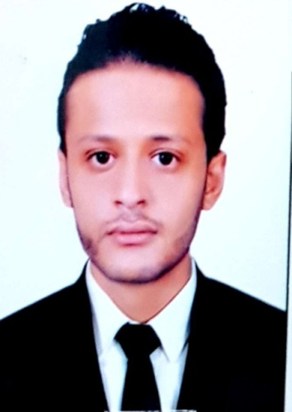
NAME: Hossny
Hossny.373006@2freemail.com
Objective
To pursue career that will develop my skills in a company that requires highly oriented individual, self-motivated and communicated well with all levels of management and fellow employees.
Work experiences:
Sales Advisor
From 2010 to 2013 (Qoura factory of paints) Egypt, Zagazig.
- Arrange merchandise on shelves according to popularity and other criteria.
- Approach customers and offer them advice on products to persuade them to buy.
- Provide information and other services such as handling returns of merchandise.
- Locate products on behalf of customers.
- Deal with complaints in a patient and helpful manner.
- Take and record orders through a computer system in person or over the phone/e-mail.
- Update customer information in databases.
- Go the “extra mile” to meet targets.
- Monitor shelves inventory and unload new products when needed.
- Operate cash registers and close daily revenues.
- Maintain a clean and orderly environment in the store.
Sales Advisor
From 2013 to 2017 (Sadyer company for Real State, Readymade and Constructions of building materials) Saudi Kingdom.

- Sell ready mix concrete, block, related products, and provide Value Engineering.
- Develop, analyze and maintain market intelligence.
- Network, Build and maintain customer relationships internally and externally.
- Quote prices, credit terms and prepare sales contracts.
- Some selected promotional activities and trade association involvement.
- Track projects from design stage to award of concrete products.
- Prepare and distribute upon request LEED ® project reports.
- Support and backup inside retail block sales.

Skills
- Good interpersonal communication.
- Fast learning and can work under time pressure.
- Analytical and problem are solving and decision making skills.
- Stress management skills and time management skills.
- Effective verbal and listening communication skills.
- Team player ability to convince and deal with various

LANGUAGE SKILLS:
Arabic the mother tongue
English good (speaking – writing)
TRAINING COURSES:
- English Course
- Marketing Course
- Leadership Course
- Strategic Planning Course
- Thinking Skills Course
- Problem Solving Course

COMPUTER SKILLS:
- Including the ability of understanding of EXCEL, WORD, Fair keyboarding skills, very good internet user.
HOBBIES:
Fashion – cars – music – internet (Estimator incidents)
EDUCATIONAL BACKGROUND:
2005 – 2009 BSC of commerce – Business Administration & accounting – ZAGAZIG University – EGYPT.
2002 – 2005 secondary Education – ZAGAZIG School – EGYPT.
PERSONAL DATA:
EXPIRY DATE: JAN- 15 – 2020
NATIONALITY: EGYPTION
Place of birth: EGYPT
Date of birth: Oct -3- 1987
Marital status: single
Religion: MUSLIM
Visa status: Visit Visa Until: Nov 18 - 2017
Current position: Sales Advisor
Driving license: I've valid Egyptian Driving license
- I hereby certify that above statement are true and correct to the best of my knowledge.

