**Shaik**

[**Shaik.373017@2freegmail.com**](mailto:Shaik.373017@2freegmail.com)

A dynamic team Spirited and performance driven engineering professional with an extraordinary blend of leadership, when it comes to enforcing regulations and responding to reported site safety concerns expressed by either public or workers. Demonstrated expertise in improving standards of safety, client, services, and job efficiency while enforcing adherence to provincial safety codes. Proved ability in identifying risks, developing solutions, drafting policies and procedures and reporting results to senior management.

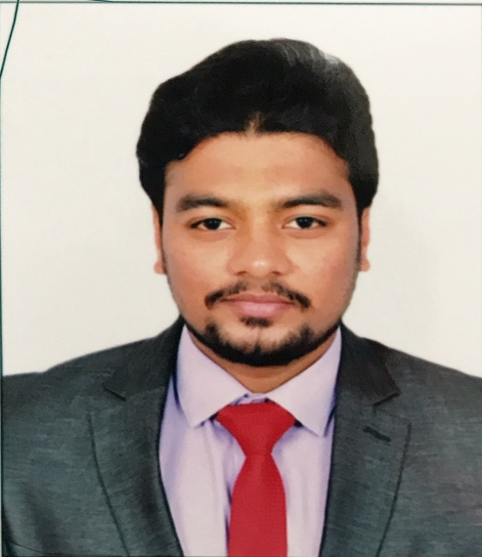

**Name : Shaik**

**Profession : Mechanical Engineer**

**Place & DOB : Abha,KSA 25 /03/1994**

**Nationality : Indian**

**Languages : English, Hindi, Urdu**

**Marital Status : Single**

**Visa Status : Visit Visa Valid 10th November 2017**

**Academic Credentials:**

|  |  |  |  |
| --- | --- | --- | --- |
| **Examination** | **Discipline/**  **Specialization** | **School/college** | **Year** |
| B.Tech | Mechanical Engineering | CVR College of Engineering | 2015 |
| Intermediate | Mathematics, Physics and Chemistry | Narayana Junior College | 2011 |
| Matriculation | Secondary School Certificate | St. Adams High School | 2009 |

**Other Qualifications:**

* Diploma in Health and safety from Professional Evaluation and Certification Board .

* Diploma in Health and Safety at Work place from NEBOSH .

* Appeared for International General Certificate exam by NEBOSH.

* QMS 9001:2015 from IRCA

* OHSAS. 18001:2007 from IRCA

**Work Experience:**

**1. Program Manager - Planning and development (Currently working part time )**

**Good Samaritans India (Not for profit social service organization)**

Good Samaritans India is a Hyderabad based NGO that rescues helpless destitute, give them medical attention if needed and shelter them in its shelter homes.

(Currently working) Hyderabad, India

* Assisting Founder in the general planning, development and management of the NGO.
* Recruiting and mentoring volunteers for leadership to achieve organizational goals.
* Helping in setting up small business along with healthy shelter inmates to empower them with a living at the same time contributing towards NGO expenses for its cause.
* Arranging monthly meetings focusing on review of activities, goals and expectations
* Constantly looking for ways to improve and make efficient the processes involved in the working of the NGO.

#### 2. Safety Trainer cum officer (September 2014- Currently working)

**Mech Turbo Pvt. Ltd. Hyderabad, India**

Mech Turbo Industries Pvt .Ltd. , Inc. was framed in light of one thing – a promise to magnificence. It was this conviction, alongside a capacity to pull in capable and steadfast representatives, which rapidly fabricated our notoriety for quality workmanship, excellent client administration, and honesty

At Mech Turbo Industries Mechanical Group we are focused on furnishing our customers with really open, interfaced items and frameworks. This puts a conclusion to exclusive and contractual worker particular practices. We trust our customers ought to have the opportunity to work with other open source frameworks and sellers. We are certain that what we set them up for proceeded with achievement and solace without the worry of using particular merchants or legitimacy frameworks and items.

**Roles and Responsibilities :-**

*To develop and recommend measures for assuring personal safety at workplace.

*To monitor and anticipate hazardous and unsafe situations

*Workplace inspections

*Accident investigation

*Regulatory compliance

**Additional experience:**

**1. Volunteer- Fund raising (August 2015- October 2016)**

**Good Samaritans India (Not for profit social service organization)**

* Helped in fund raising by approaching foundations and donors
* Helped to acquire emergency medical material whenever needed

**2. Vice-President- Divisional level ( June 2014-June 2015)**

**Street-cause CVR (Not for profit student based organization for social service)**

Street-Cause is a not for profit organization that comprising of students who intend on doing their bit for the society. It has five portfolios in each division mainly: Social impact, Environment sustainability, Women Empowerment, Old age homes and differently able, Education and orphanages.

* Manage and guide a group of 25-30 volunteers along with an Executive board.
* Set monthly and quarterly targets for each portfolio along with other board members and help in planning and execution
* Engage in frequent communication between faculty and volunteers to reach targets
* Arranging and chairing frequent meetings for Executive board members and general body to discuss ideas, developments, resolve issues etc.

**3. Coordinator: Environmental Issues: (June 2013- May 2014)**

**Street-cause CVR (Not for profit student based organization for social service)**

The objective of the team was to spread awareness about the causes of Global warming and the methods a common person can use to help save the environment.

* Plan along with the Team for monthly and quarterly targets.
* Help manage a team of five coordinators to execute events in a given time frame.



**Strengths:**

* Problem solving and problem reduction skills.
* Organizing skills.
* Consistent and hardworking
* Interpersonal relation skills
* Open minded, can analyze situations
* Able to adapt and flexible
* Quick learner.

**Extra-Curricular Activities**

* Won 2nd prize in State level presentation on “Water-crisis.”(2008)
* Presented a Paper on Vehicle-prototype at SAE-Baja India(2014)
* Karate black-belt with two Bronze medals in Nationals.
* Won the district level badminton championship.
* Executive member for the Annual College Festival “Ciencia”(2015).

**Hobbies:**

* Watching meaningful sitcoms and short-films
* Playing Cricket
* Fitness activities
* Writing on social issues
* Playing Volleyball
* Playing Indoor games

**Declaration:**

I hereby declare that the above-mentioned information is correct up to my knowledge.

**:**