Curriculum Vitae

Personal profile:
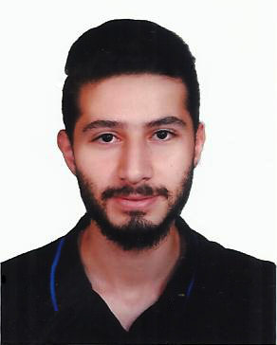
Name : Jamal
Jamal.373019@2freemail.com
Date of birth : November the 10st, 1994
Nationality : Syrian
Familial status : Single
Current residency : Damascus

Education:

Bachelors of Architecture Engineering
International University for Science &Technology (IUST) – Architecture
Syria (5 years)
Certificates:

Bachelor's Degree of Architecture

Continuing study:

Preparing for Master of Design architecture

Courses:

- Certificate of 3ds Max Design 2014 Essentials
- Certificate of 3ds Max 2014 Architectural Visualization
- Certificate of Computer Sciences and ICDL.
- Programming Course ( C language )
- Computer aided design
- Sustainable Architecture
- Quantitative analysis of housing
- Housing

Qualifications:

- Professional in AutoCAD.
- Professional in sketch up
- Professional in adobe Photoshop
- Very Good knowledge in 3ds MAX
- Good knowledge in Revit
- Good knowledge in arhcicad
- Good knowledge in illustrator
- Good knowledge in geographical information system ( GIS)
- Very good knowledge about surveying devices (Total station – level instrument (Niveau) ……)
- Advanced experience with MS Word, MS Excel, MS Outlook and so other programs.
- Ability to work independently and as part of a team and take on new tasks with high level of difficulty.
- Good knowledge about history of Architecture.
- Good knowledge in sustainable architecture
- Work with minimal up-front guidance and take ownership work product as well as work closely with all major functional leaders.
- Wide knowledge in computer and internet usage.
Research:
- Research about housing in morocco
- Research about open space
- Research about green building in the united states of America
Languages:

Language | Status
Arabic | Mother tongue
English | Very Good

Skills:

- Flexible, learning new concepts quickly, working well under pressure.
- Research Skills, attention to detail, deadline-oriented.
- Creative, addressing complaints and resolving problems.

Activities
Attending and participating in a visit to building under construction in Damascus with a Team of Architecture Engineering Students: to learn about building construction mechanism, knowledge about Material, construction tools, construction workers.
Visit to Altakiya alsulaymaniyah with a Team of Architecture Engineering Students to learn about the Syrian heritage

Note: References are available upon request.

