FAHAD | HSE ENGINEER

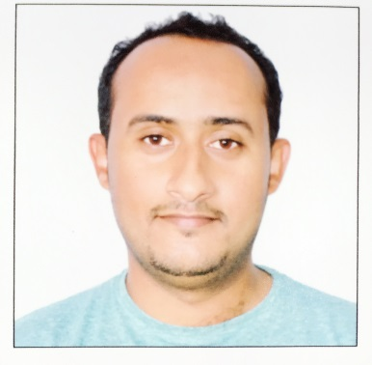 | E-mail  Fahad.373056@2freemail.com |  | EXPERIENCE  HSE Engineer| (2015 – 2017)  SAMSUNG C&T (KSA)  Responsible to Supervise Environmental impact and implementation of control measures both Samsung C&T and Sub-Contractors. Review of Samsung C&T & Sub-Contractor’s Environmental Reports and logs and provide advice for ensure compliance with PME Standards. To ensure that activities carried out are in compliance with Construction Environmental Management Plan. Liaison with Environmental Survey team. Carry out Environmental Inspections. Participate in Management Walk-throughs to for identify and environmental issues and advice preventive measures. Review Subcontractors Rehabilitation Plans and monitor its implementation. I am also responsible to supervise as a safety in the work field to provide safe environment for workers. Some of my duties are:1. Weekly walk throw with all sub-cons safety manager. 2. Daily meeting over all observations. 3. Weekly HSE MOM. 4. Top management site walk. 6. Monthly Audit on sub-contractors documents. 7. Analysis the near-miss report and close-out status. 8. Monthly color code over all tools, equipment, fire extinguishers, cables.  Packaging Supervisor | (2011)  Rabigh Petrochemical Logistic (KSA)  Responsible for supervision of Packaging process to ensure compliance with company standards. The process includes compliance with Safety and environmental standards inside the warehouse including loading & unloading.  PROFESSIONAL PROJECTS  - Rabigh 2 IPP (Present)  Acwa Power & Al-Mourjan  Kingdom of Saudi Arabia  - Petro Rabigh (2011)  Aramco  Kingdom of Saudi Arabia  PERSONAL SKILLS  COMMUNICATION  ORGANIZATION  CREATIVITY  TEAM PLAYER  SOCIAL

ABOUT ME

I am 31 years old with Two years and Six months experience in Health & Safety. I am dedicated and experienced HSE practitioner offering a rich ability in providing professional excellence in the work environment across a range of work milieu. Proven expertise in Safety and Environmental hazard identification and analysis, client/ consultant liaison, skilled communicative approach to elicit cooperation from engineering personnel. Additional capabilities are listed in the resume. I would be glad for an opportunity to discuss your needs and my potential contributions.

EDUCATION

Master Degree (Applied Engineering) (2014)

Murray, Ky United States
Murray State University, USA

Bachelor Degree (Chemical Engineering) (2011)

Ryiadh, Saudi Arabia
King Saud University, KSA

English Diploma | 2013)

Dekalb, IL United States
ELS Language Center, USA

PROFESSIONAL CERTIFICATION

- IOSH – Managing Safely| (2016)

Tamkene Saudia Training Center
Dammam, KSA

- OSHA- Occupational Safety and Health Standards for General Industry| (2017)

University of Texas at Arlington
Arlington, Tx USA

- Job Hazard Analysis | (2016)

Tamkene Saudia Training Center
Dammam, KSA

Risk & Safety Management| (2016) Tamkene Saudia Training Center
Dammam, KSA

- Basic First Aid Training | (2015)

Burear Veritas
Rabigh, KSA

- Fire Fighting & Rescue (2016)

Civil Defence
Rabigh, KSA

PROFESSIONAL SKILLS

ENVIRONMENTAL
SUPERVISION
TRAININGS
AUDIT & INSPECTIONS
SAFETY

