MUHAMMAD
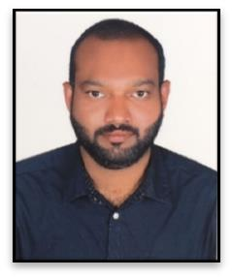

E-mail : MUHAMMAD.373057@2freemail.com

Dubai, UAE.

PERSONAL SUMMARY

An enthusiastic, bright and capable driver who is experienced enough to be able to drive as per the company schedules in a day collecting and delivering parcels and stock. A quick learner who can absorb new ideas, communicate clearly and who also possesses a good team spirit and is deadline orientated. Having a proven ability to use automatic routing or location software and to provide a efficient and prompt delivery service. Currently looking for a suitable driver position that offers variety and the opportunity to develop both personally and professionally.

SPECIAL SKILLS

- Familiarity with all the roads in the country.
- Excellent navigation and communication skills.
- Ability to deliver the goods, service or the equipment on time.

- Proven ability to use GPS and route maps.
- Able to work on a rotating shift.

- Competent at checking vehicle for problems and performing pre/post trip maintenance tasks.
- Demonstrated ability to sit and drive for long hours.

- Well-versed in cleaning of both the inside and outside of vehicle.
- Effective skills in keeping a record of miles traveled.
- Familiar with all traffic laws and regulations.

WORK EXPERIENCE
- January 2016 to Till date – Working as driver at Etisalat.

- June 2006 to August 2015 - Worked as a driver cum sales with threads tailors redefining sartorial elegance for Arabic dress material at Dubai.
- November 2003 to May 2006 - Worked as a Light vehicle driver in Oman.

- Worked as a light vehicle driver for fifteen year in India.

DRIVING LICENSE DETAILS

•
• | Date of issue | : 31 October 2006
• | Date of expiry | : 31 October 2026
• | Place Of issue | : Dubai, United Arab Emirates.

LANGUAGES KNOWN
- English, Arabic, Hindi & Malayalam.

EDUCATIONAL QUALIFICATIONS
- Secondary School Leaving Certificate (SSLC).

DECLARATION

I hereby certify that the above information are true and correct according to the best of my knowledge and belief.

Your Faithfully,

Muhammad Janeer

Place : Dubai.
Date :

