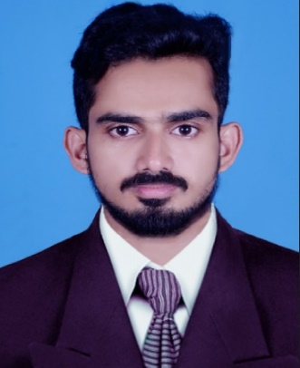  ABDUL  Email: ABDUL.373081@2freemail.com  OBJECTIVE  To integrate the professional qualifications, skills and work experience in Information Technology field with my Personal interest for a challenging work ultimately leading to the value additions to the Organizational goals.  SUMMARY  - Microsoft certified IT Professional  - Two years and nine months of total experience in IT industry with corporate networks  - Interest to learn new things and knowledge sharing to others  - Experience in server and client Operating system and network devices  - A good team player and leader on requirements  - Strong customer centric approach  PERSONAL DETAILS  - Date of Birth:12/07/1991  - Sex : Male  - Marital status : Single  - Nationality : Indian  - Visa status: Visit visa  LANGUAGES  - English:  Read ,Write & speak  - Hindi :  Read ,Write & Speak  - Malayalam :  Read , Write & Speak  - Arabic :  Read & write  - Tamil :  Speak |  | Professional Work Experience  Organization: Deloitte Haskins and Sells India Pvt. Ltd  Location: Bangalore, India  Role: IT Technical Support Engineer -Resident Onsite  Period: Feb-2015 to March-2017  Organization: Indus Motors Company Pvt. Ltd  Location: Vadakara  Role: Desktop Support Engineer  Period: Jul-2014 to Jan 2015  Responsibilities  - Installed, configured, and maintained the functionality of company computer systems, together with peripheral appendages and software.  - Giving proper response to the communication mails and calls  - Resolving issues through remotely using SCCM and Skype for business  - Responsible for ADS User and Computer account management.  - Installation and troubleshooting of MS Office 2010,13 and O365  - Installing and configuring company applications and MDM software  - Handling Domain level issues of ADDS,DNS,DHCP and IIS  - Configuring, managing and monitoring Network Devices.  - Providing support for maintains and up gradation of network devices and peripherals  - Internet and LAN configuration, troubleshooting  - Installing and updating Antivirus in closed interval  - Manage shared folder and devices through permission  - Kept in constant touch with vendors to resolve problems as quickly and efficiently as possible.  - Configuring and troubleshooting IP Phones  - Installing and troubleshooting VPN applications  - Hardware replacing and upgrading for Desktops and Laptops  - Proactively monitoring and resolving the issue within the given SLA.  - Installation, Configuration and Troubleshooting of Local and Network Printers  - Supporting and arranging meeting rooms.  - Installation, maintaining and testing CCTV devices.  - Handling asset implementation and stock inventory  Key Strength  - Ability to learn new technologies & adapt to new surroundings abruptly  - Ability to work under pressure and meet deadline  - Punctuality & dedication towards work  - Creativity & Imaginative Power  - Productive working relationships with clients and staff  - Believe in teamwork  Technical Skill  - OS installation: - Win XP, Win Vista, Windows 7 , Win 8, Win10 and Win Server 2012  - Installing and configuring Active Directory Win 2012 Server  - Configuring DNS, DHCP And Group policy management  - Assembling, hardware up gradation and troubleshooting of Desktops  - Configuration knowledge of Cisco switches and routers.  - Knowledge of VLAN configuration with VLAN trunk and VLAN Access mode.  - Ability to configure and troubleshoot RIP V1 & V2, EIGRP, IGRP and OSPF routing protocol and NAT  - Remote desktop and Remote assistance  - Sharing folder, sharing device & Printers.  - Expert in resolving software and hardware issues of Client machine  - Installation, configuration, integration, testing and Maintenance of IP CCTV.  Academic Qualifications  COURSE INSTITUTE BOARD/UNIVERSITY  B.sc Physics M.H.E.S College Calicut University (2010-13)  Plus Two Gov VHSS Madappally Kerala State (2008-10)  SSLC Memunda HSS Vatakara Kerala State (2006-08)  Certification and Course Completed  - MCSE 2012 SERVER-  - CCNA  - HARDWARE AND NETWORKING  Declaration  I hereby declare that all details finished above are true to the best of my knowledge and belief.  Date:14/09/2017  Place: Dubai

